Configure Purchase Order Routing Method and Notifications

1. Login to your supplier account at supplier.ariba.com
2. Click initials in top right hand corner of homepage and click settings:

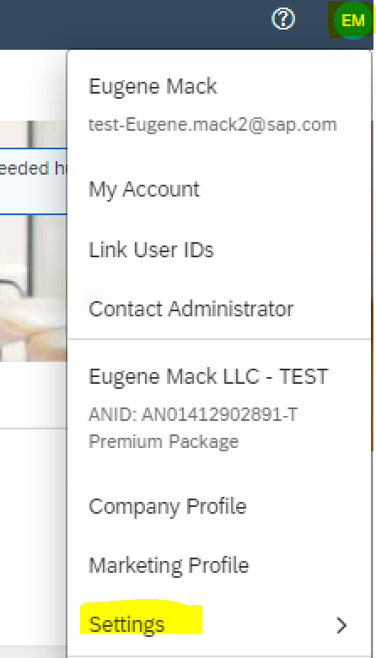

1. Select “Electronic Order Routing”

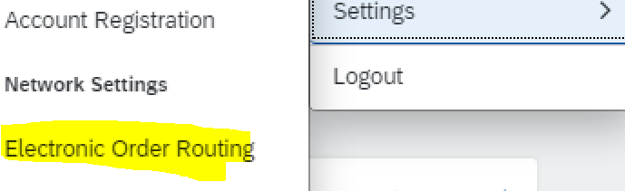

1. In the New orders section find the “New catalog orders without attachments” document type and select “email”. Then in the email address box on the right hand side insert up to 3 email addresses who you would like to receive a copy of the PO (ensure email addresses are separated by a comma and no space). You may also select the check box of how you would like the PO to show within the email:

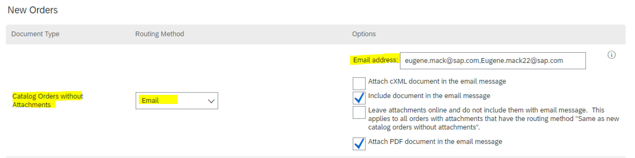

1. Scroll down to the bottom of the screen until you see “Notifications” and select the specific notifications you would like to receive regarding your Purchase Orders. You may also add up to three email addresses to receive these notifications (as long as they are separated by a comma and no space):

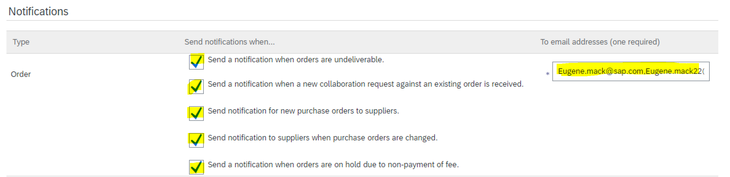

1. Click “Save” at the bottom of the screen to save your settings:

