Ariba Help Mass Confirm Doc Link

Download
Log into Ariba and click the triple dots in the top right corner. Select upload/download from the menu that appears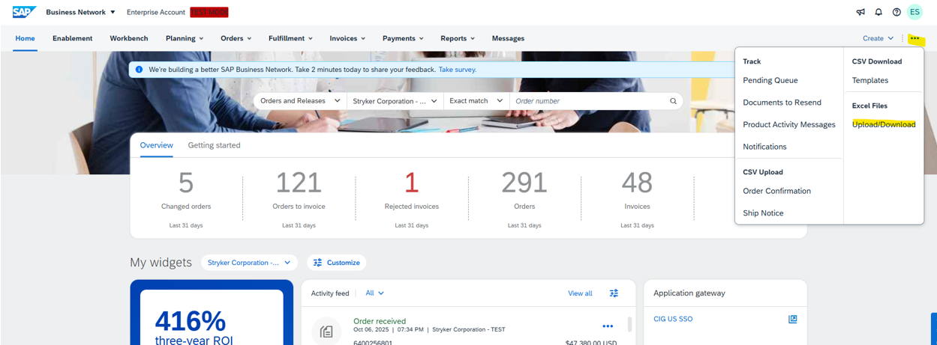
Under the job tab click Create. If you already have an existing job you can select the radial button and click Run to generate a new report. You can also select Edit to modify the parameters of the existing job. If you do not have access to the upload/download connect with your Ariba Administrator.
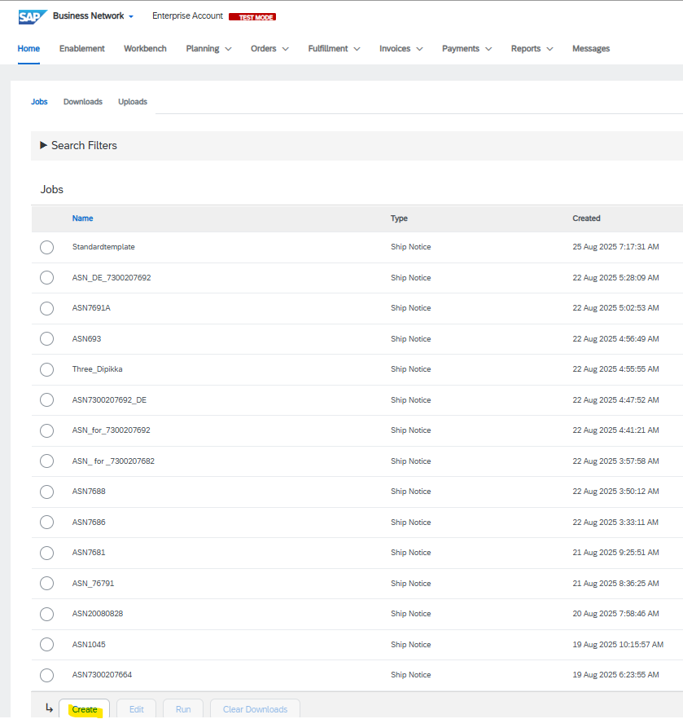
On the job creation screen, name the job, select order confirmation as the type
- be sure to check the “include already-confirmed data” checkbox
- modify any other parameters as you would see fit such as date range.
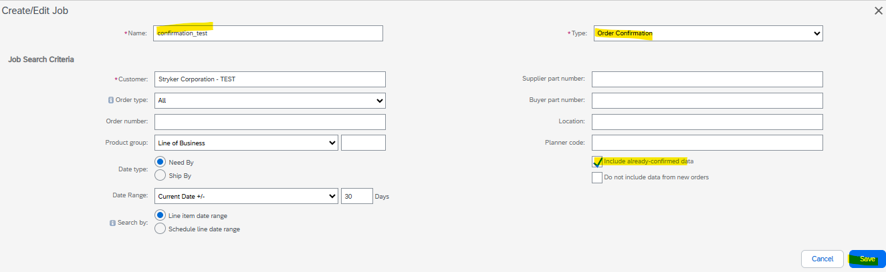
After creating or modifying your job, select it on the radial dial and press “Run”.
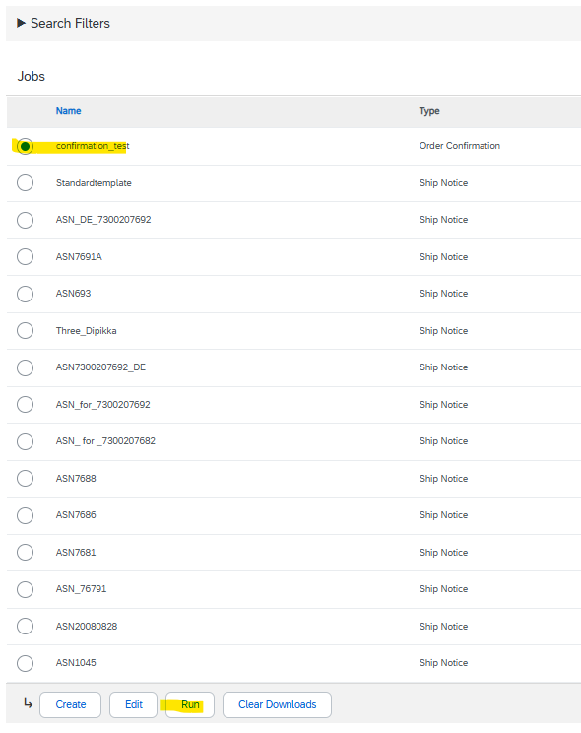
You will automatically be taken to the Downloads tab and you will see the job go into processing status. Click Refresh status until it changes to completed status

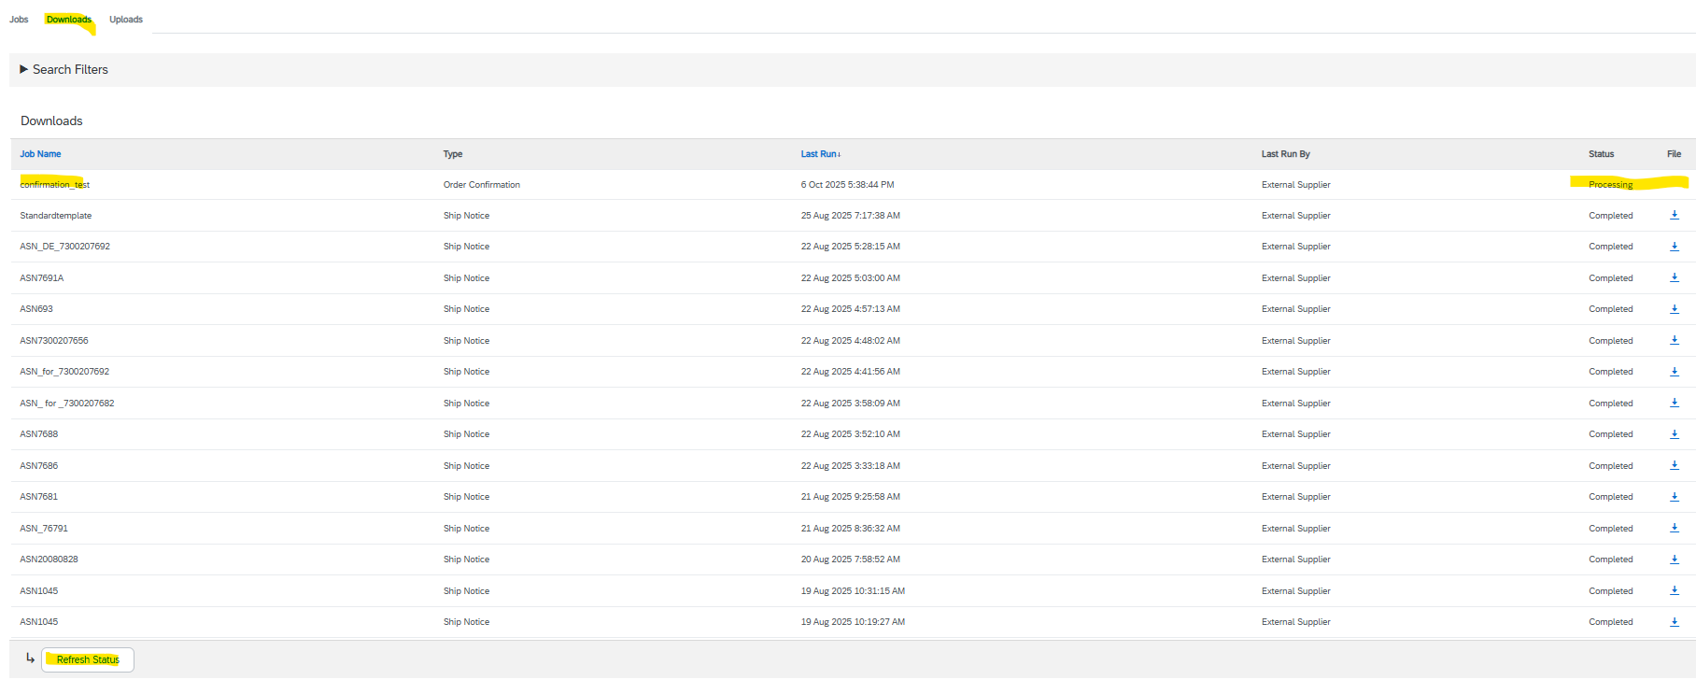
Once it’s Completed you will see a download button you can click to download the report.
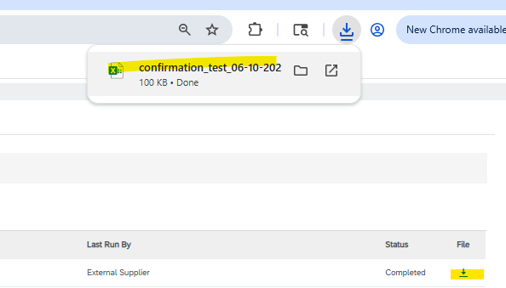

Review
When reviewing the downloaded file there’s a couple columns worth noting.
- Confirmation Number: The number entered on the create confirmation screen.
  - This can also be used similar to “Current Status” to tell if you’ve confirmed that order and line
- Order Number (*) & Item Line number (*)
  - If you see duplicates it is because the confirmation split the PO quantity into multiple delivery dates
- Current Status – Tells you whether or not you have confirmed this PO line.
  - This is important to note as unconfirmed PO lines will put the PO Need By Date as the Delivery date for unconfirmed POs which may errantly lead you to believing these are confirmed
- Item Customer Part ID: Stryker’s Part Number
- Item Revision Level
- Requested Quantity & Confirmation Quantity (*)
  - If you see a mismatch you have either partially confirmed or split the line between delivery dates
- Item Unit of Measure (*)
- Need by Date: Stryker’s originally requested delivery date for the full shipped quantity
- Delivery Date: Either the date you confirmed the product would be delivered or if the line is unconfirmed, defaults to the Need by Date. See note on Current Status

