How to upload serial numbers to an ASN:
- Choose the “Manage Serial numbers” button and “Download Template” for the
template you will used to submit the ASN data.
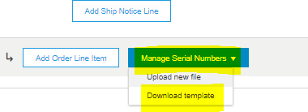

- Input all necessary data for the specific ASN (Serial number, Production date, start date and expiration date). The date fields will need to be inputted in the date format shown in the excel. Examples:
  - Production Date: 03/01/2018 (Format: 2018-03-01T09:26:32-07:00)
  - Expiration Date: 03/01/2019 (Format: 2019-03-01T09:26:32-07:00)

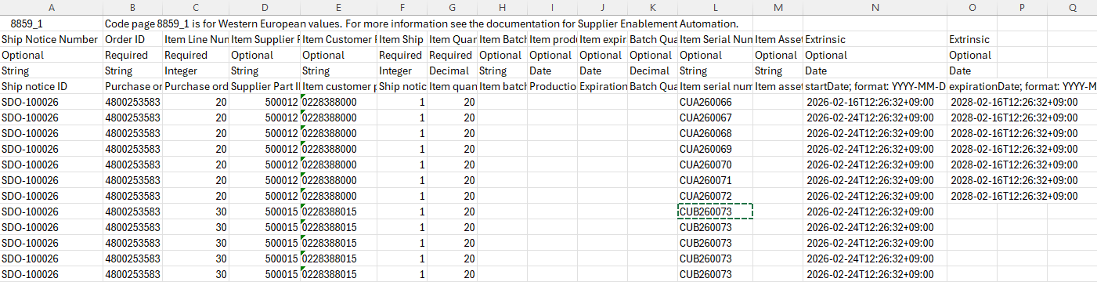
- Note that the file should be filled out exactly as above with serial production and expiration dates (if applicable) going in the columns labeled as “startDate” and “expirationDate”
- Columns I & J are labeled as production and expiration date fields but these are for batch information not serial information.
- For serialized product, batch information must not be provided as it will cause the ASN to fail upon integration to Stryker.

- Save the CSV file to your computer
- Go back to the “Manage Serial Numbers” button and choose “Upload New File”
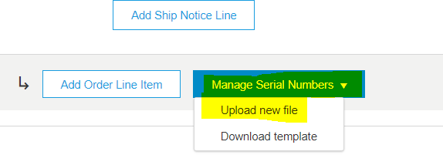
- First, “choose file”, then click “add attachment”
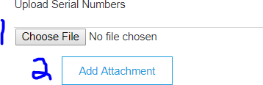

- All relevant serial numbers, production and expiration date information will be
visible in the “add details” section of the ASN UI.
- Follow normal ASN submission process steps.
