**Indirect Channel**

**Resource Center**

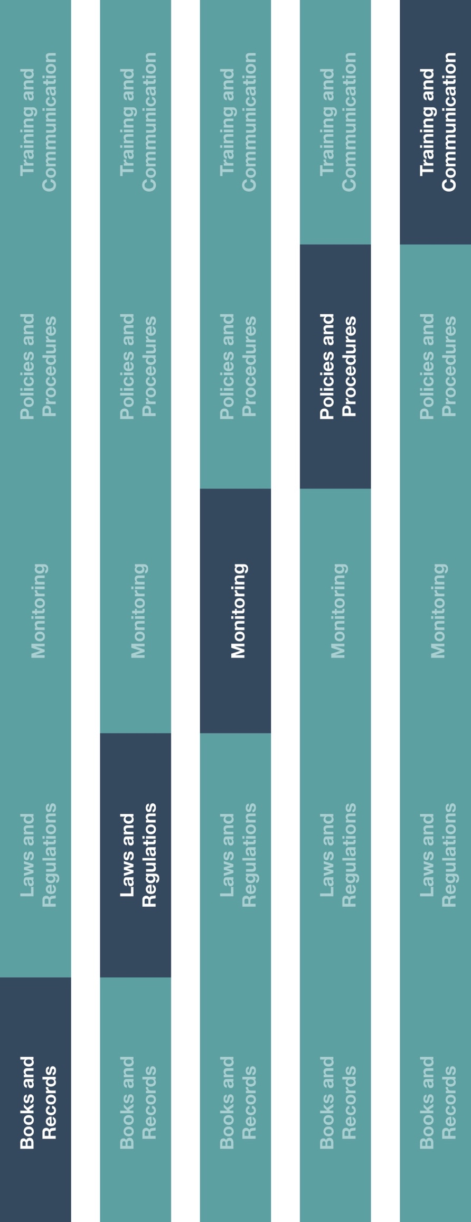

**Grant, Donation and Sponsorship Policy**

*Version 1.0*

|  |
| --- |
| **Description**  The Grant, Donation and Sponsorship Policy establishes guidance when providing  financial support in the form of grants, donations and sponsorships.  Prior to providing financial support, written approval as well as an executed agreement is required. Furthermore, grants, donations and sponsorships should not be used to gain improper advantages to influence purchasing decisions and payments should not be made directly to healthcare professionals (HCPs) or private practices affiliated with HCPs. |



**Other documentation to consider**

* Grant, Donation and Sponsorship Request Form
* Grant, Donation and Sponsorship Agreement Template
* Code of Conduct
* HCP and Government Official Interactions Guidance



**Instructions**

1. Customize the highlighted sections of the Grant, Donation and Sponsorship Policy.
2. Provide the Grant, Donation and Sponsorship Policy to relevant employee(s).
3. Ensure the employee(s) in charge of approving grants donations and sponsorships understand their duties and responsibilities and the requirements associated with the Grant, Donation and Sponsorship Request Form and Agreement Template.
4. Ensure grants, donations and sponsorships receive appropriate approval, that approval is documented and supporting documentation is maintained.

*Please consider all local industry code(s) (e.g., AdvaMed) and local laws when interacting with healthcare professionals or government officials

**How does this benefit you?**

The Grant, Donation and Sponsorship Policy is designed to ensure your company is compliant with highly scrutinized, compliance sensitive, interactions. Adopting this policy will protect your company’s reputation, your employees and your customers.



# **GRANT, DONATION AND SPONSORSHIP POLICY**

**[insert company name]** is committed to enhancing the medical profession and supporting our community. As such, we may provide financial support to organizations that we feel have similar interests and goals. This policy provides guidance in terms of the types of acceptable financial contributions and in-kind charitable donations and related documentation.

# **RELEVANT DEFINITIONS**

**Grant** - Anything of value provided for a specific purpose. A grant generally requires the performance of some act that something of value will be received in return.

**Charitable Donation** - Charitable giving of anything of value to a charitable organization, as defined by local regulations, engaged in bona fide charitable work.

**Sponsorship** - Anything of value (typically a monetary and/or in-kind payment) made in exchange for recognition or advertising at an event such as bag inserts, signage or other public acknowledgements.

# **ACCEPTABLE FINANCIAL CONTRIBUTIONS**

Financial support can be provided in the form of grants, donations and sponsorships for philanthropic or educational purposes. However, all financial support must be made in accordance with applicable local laws and policies and must be approved prior to being provided.

**FUNDAMENTAL PRINCIPLES**

* All grants, donations and sponsorships should be made at reasonable commercial value with no intention of gaining an improper market benefit.
* Grants, donations and sponsorships should not be used to influence purchasing decisions or product use.
* Sales personnel should not be involved in approving or funding decisions related to grants, donations and sponsorships.
* All contributions should be open and transparent (e.g., supporting documentation should include business purpose and recipient).
* All grants, donations and sponsorships should receive proper approvals from **[insert approver name(s)/title(s) here]** from relevant governing bodies when necessary.
* All approved grants, donations and sponsorships contributed to should have a written agreement prior to fund payment.
* Payments to individual HCPs or private practices affiliated with HCPs are not permitted.
* Any conflicts of interest related to the support and/or recipient organization must be disclosed.
* Donations may be made only to legitimate charity organizations or non-profit organizations with tax-exempt status.
* No charitable donation requests to a bona fide organization should be made in response to requests made by HCPs, unless the HCP is an employee or officer of the organization and submits the request on behalf of the organization.
* Sponsorship of HCPs to attend a Third Party Educational Conference is not allowed.

**PROCEDURE RELATED TO FINANCIAL CONTRIBUTIONS**

1. Grant, Donation and Sponsorship Request Form and relevant supporting documentation should be completed by the applicable party that meet the above mentioned criteria and are seeking support. No “unrestricted” financial support may be given.
2. Requests are then reviewed by **[insert approver name(s)/title(s) here]** and approved, if deemed appropriate.
3. **[insert approver name(s)/title(s) here]** must ensure that both the location (city and country) and the venue (type of facility) of the Third Party Educational Conference are appropriate. The location and venue must be appropriate for, and conducive to (i) accomplishing the legitimate purpose of the educational conference; and (ii) be suitable for and conducive to the effective exchange of educational, scientific or business information between attendees.
4. Recipients of approved requests must enter into an agreement which outlines the expectations and responsibilities of all parties. Representatives from both the **[insert company name]** and receiving party must enter and execute an agreement utilizing the Grant, Donation and Sponsorship Agreement Template.
5. Financial support will be distributed to receiving parties as outlined in the Grant, Donation and Sponsorship Agreement. Financial support cannot be funded by cash or credit card.