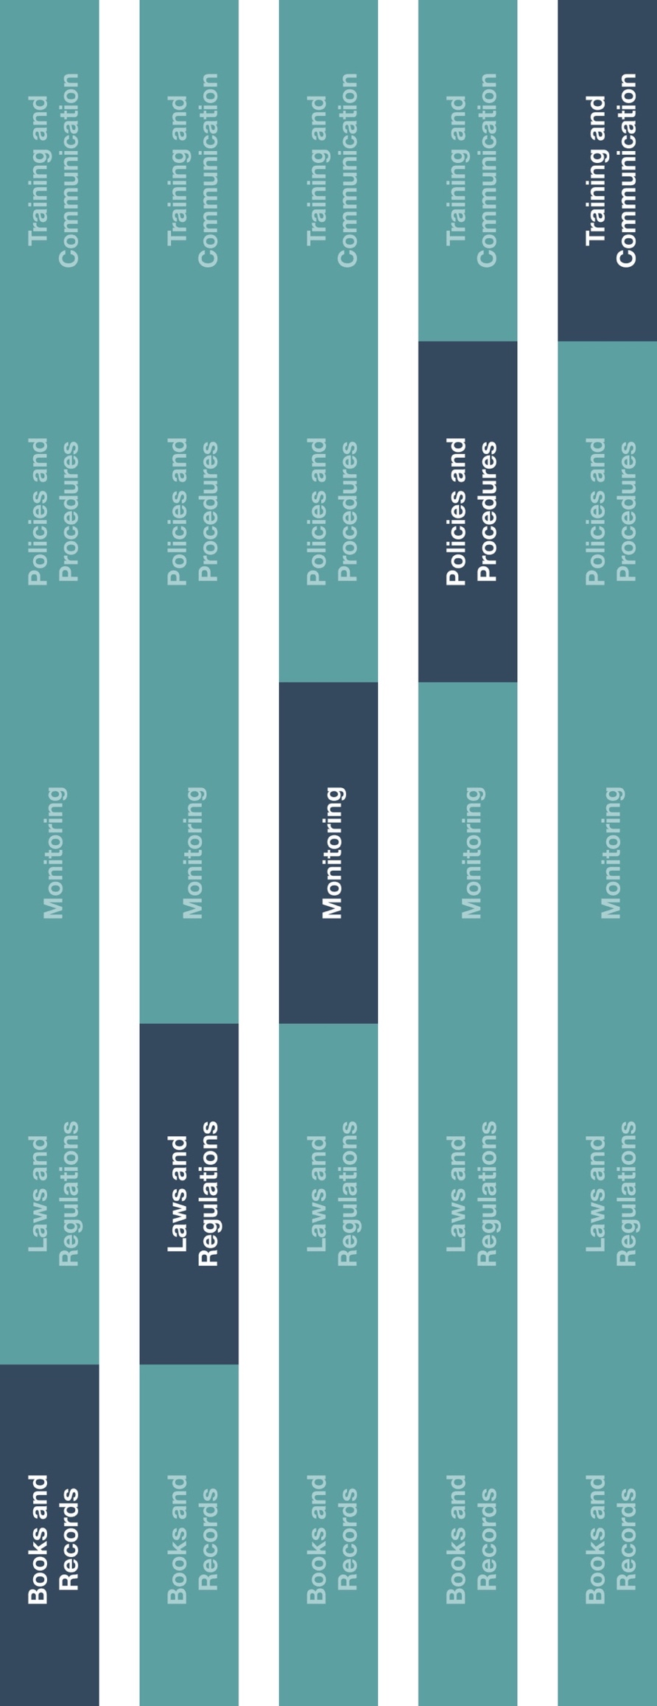

**Indirect Channel**

**Resource Center**



**Instructions**

1. Provide Grant, Donation and Sponsorship Form to employee(s) responsible for approving payments related to grants, donations and/or sponsorships.
2. Ensure that relevant employees are aware of the Grant, Donation and Sponsorship Form and your company’s policy regarding the approval and payment of grants, donations and/or sponsorships.

**How does this benefit you?**

Documenting grants, donations and sponsorships will help you record business transactions in reasonable detail and help maintain an adequate system of internal accounting controls. Accurate books and records will assist your business with planning, budgeting, reporting and allocating resources.  
  
Grants, donations and sponsorships must not be provided as an unlawful inducement or encouragement to purchase, lease or recommend the use of any product or service. Sales and marketing personnel should not be involved in or seek to influence the grant, donation and sponsorship approval process.



**Other documentation to consider**

* Grant, Donation and Sponsorship Policy
* Books and Records Guidance

**Grant, Donation and Sponsorship Form**

|  |
| --- |
| **Description**  The Grant, Donation and Sponsorship Form should be used to document funding requests and approvals related to grant, donation and/or sponsorship activities. |



*Version 1.0*

# **GRANT, DONATION AND SPONSORSHIP FORM**

|  |  |  |
| --- | --- | --- |
| **Transaction Information** | | |
| Recipient name and identification number (e.g., tax ID, VAT number, etc.): |  | |
| Amount and currency[1]: |  | |
| Recipient address (including country): |  | |
| Purpose of the grant, donation and/or sponsorship: |  | |
| Event name: | | Event date(s): |
| Event location: | | Event address: |
| Supporting documentation: | Please attach supporting documentation related to the request (e.g., organization’s request letter / proposal, agenda, etc.). | |

|  |
| --- |
| **Certification** |
| I confirm that the information provided is accurate and complete, to the best of my knowledge. I further certify that this payment is not being offered to reward customers or as an inducement or encouragement to recommend or purchase company products or services, and is not tied to past, present or future use of company products or services. |
| Requested by: Date: |

|  |  |
| --- | --- |
| **Approval** | |
| Approved amount: |  |
| Approved by: Date: | |

1. Please note that transparency reporting requirements may apply. Please check local laws and regulations for specific requirements.

   *This request should also consider any additional local regulations.