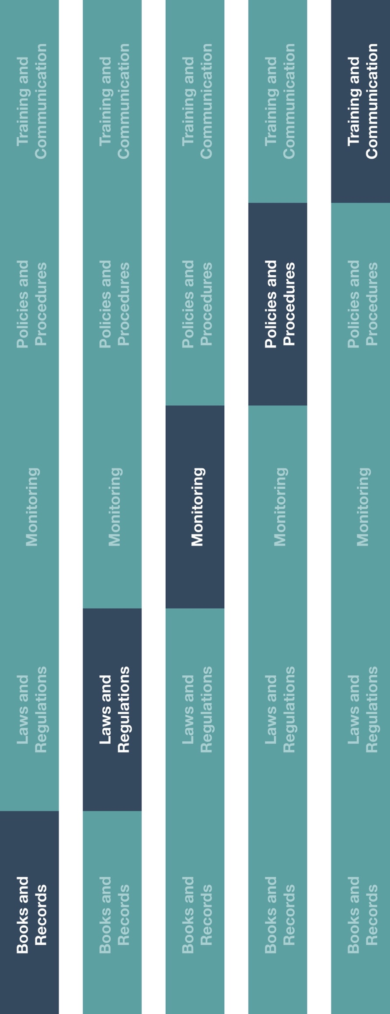

**Indirect Channel**

**Resource Center**



**Other documentation to consider**

* Grant, Donation and Sponsorship Form
* Grant, Donation and Sponsorship Policy



**Instructions**

1. Customize the highlighted sections of the HCP Employer Notification template.
2. Provide the Grant, Donation and Sponsorship Agreement Template to employees and ensure they are aware of the applicable policies and procedures.
3. Ensure grant, donation or sponsorship funding is available, required supporting documentation and requests are provided/completed and requests are adequately approved.
4. Once approved, complete and execute the Grant, Donation and Sponsorship Agreement Template.
5. Ensure payments made are processed in accordance with the agreement and applicable supporting documentation has been provided proving that funds have been used for the documented purpose.

|  |
| --- |
| **Description**  The Grant, Donation and Sponsorship Agreement Template should be used to  document financial support with the recipients of funds related to grants, donations  and/or sponsorship activities. |



**How does this benefit you?**

A written agreement for grants, donations and sponsorships will help ensure you have necessary supporting documentation for the transactions and help maintain an adequate system of internal controls. Further, it will ensure that the amount paid is consistent with terms of the associated agreement.

Grants, donations and sponsorships must not be provided as an unlawful inducement or encouragement to purchase, lease or recommend the use of any product or service. Financial support for grants, donations and sponsorships must be reasonable and appropriate.



*Version 1.0*

**Grant, Donation and Sponsorship Agreement Template**

**GRANT, DONATION AND SPONSORSHIP AGREEMENT TEMPLATE**

This is an Agreement between **[Insert company name],** a company located at **[insert address], (“Benefactor”)** and **[Insert company name],** located at **[insert address],** (**“Recipient”).** This Agreement will be governed by the laws of **[insert governing law].**

Funding for the **[grant/donation/sponsorship]** will be provided to the **Recipient** for the purpose of **[insert purpose]** hereafter referred to as the “**Purpose.**”

The **Benefactor** intends to provide financial support for the **Purpose** and the **Recipient** agrees to accept and apply such funds solely based on the terms and conditions of this Agreement.

**Terms and Conditions:**

1. **Financial Contribution**. The **Benefactor** will provide payment to the **Recipient** in the amount of **[insert amount and currency]** for the sole purpose as defined above **[grant/donation/sponsorship]**.

2. **Payment**. The **Recipient** shall keep accurate books and records with reasonable support. Payment will be made to the **Recipient** by **[insert payment method]** each **[insert timeframe** beginning **[insert payment date]** and ending **[insert payment end date],** provided there are no contractual breaches and supporting documentation has been provided. The **Benefactor** will manage the funds and payment.

3. **Application of Financial Contribution.** The funds shall be applied by the **Recipient** only to cover the **Purpose** of **[grant/donation/sponsorship]** as defined above**.** The contribution shall solely be applied to cover costs and expenses that directly relate to this purpose and shall not be used directly or indirectly for any other purpose. Any application of funds outside the Purpose shall be subject to Benefactor’s prior written approval. Misapplication of funds may result in the termination of this Agreement and the defunding of the **[grant/donation/sponsorship].**

4. **Confidentiality and Communication**. Both the **Benefactor** and the **Recipient** shall not disclose such information to any third-party without prior written authorization of the party to whom such information relates unless information is publicly available. This includes in advertising and business activities.

5. **Compliance**

(i)It shall be the **Recipient’s** sole responsibility to ensure compliance with applicable laws and regulations, the highest ethical standards.

(ii) The **Recipient** represents that it is fully aware of the **Benefactor’s** Code of Conduct (or applicable policy) and local and foreign anti-bribery anti-corruption laws in force in the jurisdiction of its place of business and/ or activity (including, however not limited to, the United States Foreign Corrupt Practices Act). The **Recipient** also represents that the monies paid to it hereunder will not be received or otherwise used to make or offer an improper payment to any government official.

(iii) Upon request, the **Recipient** will provide to the **Benefactor** supporting documentation and/or data to provide assurance that all funds have been utilized according to the terms of this agreement.

6. **Undue Influence.** The **Benefactor** shall not obligate in any way the **Recipient** to purchase, use, recommend or arrange for the use of medical products.

7. **Severability.** Should any part of this Agreement be held unenforceable or in conflict with the applicable laws or regulations related to this Agreement, this Agreement must be updated to be in accordance with the new law or regulation and agreed upon by both parties.

8. **Transparency**. Applicable laws and/or ethical codes may require transparency disclosures. It is the responsibility of both parties who enter into this agreement to ensure relevant transparency policies and public disclosures are followed.

**9. Execution:**

**Recipient Benefactor**

Signature: __________________________________ Signature __________________________________ Name: ____________________________________ Name: ____________________________________ Title: ______________________________________ Title: ___________________________________ Date: _____________________ Date: _____________________