Indirect Channel guidance Document
RAQA Intake Form

Service supported by Indirect Channel triggers applicable RAQA section and corresponding obligation of the RAQA Intake form in the IC Hub, non-applicable section does not show up

Section header – (1) Storage, Handling and Transportation of Products
 |  | Guidance for Indirect channel (IC)
1 | Do you have any provision to take into consideration product storage condition according to Manufacturer information indicated on product labelling? | We are looking at Indirect channel ability to appropriately store products according to manufacturer specification, (Temperate/humidity control area)  As an Indirect channel, how do you ensure that product is stored in temperature-controlled area which means that any product with specific storage condition is kept within the required temperature range?
1a | If No or Not Applicable, please describe the reason why? | It is not applicable; the Indirect channel doesn’t store any product with specific storage condition.  Select “no” if you have temperature-controlled product without any provision in place
2 | Do you have a process to monitor the temperature of products requiring specified storage conditions? | If Indirect Channel is storing temperature-controlled product, how IC is monitoring the temperature of the storage area.
2a | Please provide any documented evidence of registered temperature log and the type of temperature system/device used. | Example Evidence:  Temperature record or daily log/table of the temperature or Work Instruction. See example of temperature log, in annex 1
2b | If No or Not Applicable, please describe the reason why? | It is not applicable if the Indirect channel doesn’t store any product with specific storage condition.  Select “no” if you don’t have any documented evidence in place
3 | Do you have any Procedures and/or Work Instructions available for product storage and transportation? | Do you have a written internal process defining the provision for product storage and transportation to ensure product preservation? If so, select “Yes” otherwise select “No”.
3a | If yes, please provide any documented evidence such as process flow and/or procedure and/or work instruction AND transportation agreement, ... to identify provisions for product storage and transportation. | This question will only appear if you select “Yes” above.  In case you do not have a written process, please provide in writing the provision implemented to control product storage and transportation.
4 | Are products stored in suitable conditions to prevent product mix up and deterioration? | What are the provisions you have implemented to avoid product mix up and product deterioration i.e not exposed to direct sunlight, dusty, humidity in the storage area?
4a | If yes, please provide documented evidence: photo(s) of warehouse/Product storage. | Please provide photos of the warehouse to demonstrate how products are stored. i.e photo of the shelves, cabinets or any storage area where product is stored.
5 | Do you have a process in place to manage pest control? | The Indirect Channel should ensure that there are no pest issues where products are stored. Any provision in place to control pest i.e., periodic spraying of pesticide on site or placement of rodent repellent etc.
5a | If yes, please provide any documented evidence, procedure and/or agreement with pest control company and/or landlord agreement and/or recent invoice from pest control company or any other type of evidence. | Evidence that can be provide here could be an invoice/agreement of a third-party company performing periodic fumigation or alternatively to provide written summary of the provision implemented to prevent pest in the storage area.
6 | Do you have a process to take appropriate action if the temperature exceeds limits corresponding to stored products? | IC will answer “Yes” to the question if you defined some action to implement in case, the temperature in your warehouse exceeds limits.
6a | Please provide any evidence: documented procedure and/or Work Instruction and/or a memo identifying actions taken in this scenario. | IC should share procedure or process if documented otherwise, please provide a written summary of actions taken when the temperature exceeds the limits.
6b | If No or Not Applicable, please describe the reason why? | Not Applicable: if you don’t store product requiring temperature control.  No: If you don’t have any provision for temperature control.  In both options, please provide justification.
7 | Do you perform goods in and/or goods out inspection of the products you are distributing? (i.e. quantity, appearance and packaging integrity, expiry date etc.) | Are you checking the integrity (i.e. quantity, appearance and packaging integrity, expiry date etc.) of the product when you receive it and perform the same checks when you are shipping products to customer?
7a | If yes, please provide any documented evidence e.g., Procedure or  Work Instruction and/or Form and/or any documents demonstrating Goods in and/or Good out inspection. | The type of example you can provide is:  Procedure or Work Instruction or Form or written summary of steps taken to ensure product integrity when the product comes in your facility and when product goes out to customer.
8 | Are there regular checks of stock (cycle counting)? | Is the Indirect Channel performing verification (quantity, Serial/lot number) of the physical inventory matches with data available in ERP system?
9 | Do you have a process to control product expiry dates? | The objective is to ensure that the product in inventory and the product shipped to sub-Indirect Channel or end user have enough remaining lifetime.
9a | If No or Not Applicable, please describe the reason why? | If Indirect Channel does not store any product with expiry date, it will not be applicable. Please describe the reason why?
10 | Do you have a process for segregation of Non-Conforming Products? | Do you have a specific and identified area separated from inventory to store non-conforming product?
10a | If yes, please provide any documented evidence e.g., Procedure and/or Work Instruction and/or Photos or layout. | Example of evidence:  Procedure or Work Instruction or Photo or layout.
Section header – (2) Traceability
11 | Do you have a system to manage product traceability? | Any provision to identify product (Reference, Quantity, Lot/Serial, Supplier ID at inbound and Reference, Quantity, Lot/Serial Customer ID at outbound).
11a | If yes, please provide any documented traceability evidence records i.e. printed document or screenshot with the following minimum requirements. (Item No, Quantity, Shipment site (Hospital end -user name) | Please see example of documented evidence – ERP Screenshot – in annex 2
12 | Are all products traceable by LOT / serial number? | Select “Yes” if you are tracking lot/serial number for each product.
13 | Can scrapped products be traced? | The intent is to ensure that IC has traceability record for identifying products that are scrapped.  Note: It will be needed in case of quantity reconciliation for Product Field Action.
13a | If yes, please provide any documented evidence: traceability record or screenshot of scrapped products by serial/Lot and/or certificate from a third-party scrap company. | Evidence of transaction to scrap location or a certificate from the third-party company with serial/lot number.
14 | Do you have a documented process to control product traceability? | Select “Yes” if you have a written document identifying traceability provision.
14a | If yes, please provide any documented evidence i.e., procedure and/or work instruction and/or process flow. | Provide written documented evidence of traceability provision in a procedure and/or work instruction and/or process flow.
Section header – (3) Post Market Surveillance
15 | In the event of a recall or Product Field Action, do you have the ability to identify physical location of each product? | The intent is to ensure that Indirect Channel can identify location of any product under their responsibility.
16 | Do you have any established notification/communication process with customer in case of Recall or Product Field Action? | The intent is to ensure there is a clear responsibility identified within the Indirect Channel organization to support Recall or Product Field Action in a timely manner to avoid using potential non-conforming products.
16a | If yes, please provide any documented evidence, example of Recall or Product Field Action notification to customer. | Please provide an example of notification or communication sent to customer related to Recall or Product Field Action.
17 | For Product being returned to Stryker location, can you adequately decontaminate products and provide any evidence of decontamination before shipment? | The intention is to prevent risk of cross contamination during transit and to protect employees handling products.
17a | If yes, please provide any documented evidence such as document confirming decontamination. | Example evidence:  An internal document provided by the Indirect Channel to demonstrate that products are decontaminated. See example of decontamination certificate, in annex 3
17b | If no or not Applicable, please describe the reason why? | Please provide justification for selecting “No” or “Not applicable”.
18 | Do you have a documented procedure for managing Recall or Product Field Action? | Select “Yes” if you have any written document identifying provisions for managing Recall or Product Field Action.
18a | If yes, please provide any documented evidence i.e., procedure and/or work instruction and/or process flowchart. | Please provide written Recall or Product Field Action provisions documented in a procedure and/or work instruction and/or process flow.
19 | Do you maintain record retention and accessibility for Recall or Product Field Action? | The intent is for the Indirect Channel to store all applicable records (communication, reminder, evidence of product return) related to Recall or Product Field Action that can be requested by regulatory authorities
19a | If yes, please provide any documented evidence (procedure and/or flowchart and/or work instruction and/or memo). | The intent is to identify which documents are kept and for how long?
Section header – (4) Product Complaints
20 | Do you have a process for reporting product complaints to manufacturer? | Select “Yes” if you have any provision in place to communicate to manufacturer any product complaint.
20a | If yes, please provide any documented evidence (procedure and/or Form and/or flowchart and/or work instruction). | Please provide the form, you are using for reporting product complaint or and instruction or flow chart. See example of Product Inquiry Form in annex 4
21 | Do you define in your documentation one business day timeframe to report product complaints to manufacturer from date of awareness? | Did you specify in your documentation that the communication to manufacturer has be done within one business day?
22 | Do you have adequate record retention and accessibility for product complaint? | The intent is for the Indirect Channel to store all records (communication, reminder, evidence of product return) related to products complaints.
22a | If yes, please provide any documented evidence e.g., Procedure or Work Instruction or Memo. | Example of documented evidence: Procedure or Work Instruction or Memo.
Section header (5) Sub-Indirect Channel
23 | Do you have a Quality Agreement signed with your Sub-ICs? | Select “Yes” if you have a Sub-IC and a quality agreement with them.
23a | If yes, please provide copy of the quality agreement template. | Please provide copy of the agreement or an overview of the obligations covered in the agreement.
Section header (6) Regulatory Affairs Requirements
24 | Do you have a process to ensure product registration/notification to relevant local authority is valid and up to date? | It is only applicable in country where we do not have a Stryker presence  It’s only applicable, if the Indirect Channel is performing any product registration/market authorization activity with the authorities.
24a | If yes, please provide documented evidence. | Example Evidence:  Procedure or Work Instruction or Memo and/or confirmation of product registration/market authorization from local authority.
25 | Do you ensure any local regulatory requirement changes are communicated to manufacturer representative? | It is only applicable in country where we do not have a Stryker presence. The intention is for the Indirect Channel to communicate any local regulation change to the Stryker representative RAQA team.
25a | If No or Not Applicable, please describe the reason why? | It is only applicable where we do not have a Stryker presence in the country.
26 | Are you translating any labelling (including IFU's, product labels, operative techniques) in local language? | It is only applicable when local language is not available on labelling
26a | If yes, please provide documented evidence corresponding to the process in place | Please provide documented evidence identifying the translation process in place.
27 | Do you perform any product supplemental labelling for distribution? e.g., Importer or distributor name and address. | It is only applicable when Indirect Channel adds importer/distributor identification on product.
27a | If yes, please provide documented evidence. | Please provide documented evidence identifying the process in place for adding importer/distributor identification on product.
28 | Do you perform any type of re-packaging /splitting multipack products? | It is applicable when changing the original packaging of the manufacturer from multipack to single pack in country where market requirements are single pack only.
28a | If yes, please provide documented evidence. | Please provide documented evidence identifying the process in place for re-packaging /splitting multipack products.
Section header – (7) Surgical Set process, cleaning, and disinfection
29 | Do you manage and process non-sterile reusable instrument sets / Surgical Sets? | The intention is to understand how the Indirect Channel is supporting surgical set for implant divisions. Shipped to hospital for planned surgeries and receiving surgical sets back post-surgery.
29a | If yes, please provide documented evidence, e.g., Process flow and layout photo(s) of surgical set room(s). | Please provide documented evidence identifying the process covering different steps of the process
30 | Do you ensure surgical set traceability? | The intention is to ensure that the Indirect Channel can identify the exact location of surgical set and its content, in case of any Recall or Product Field Action.
30a | If yes, please provide documented evidence e.g. list of surgical sets and their current physical location(s) | Please provide documented evidence identifying the process of traceability applicable to surgical set.
31 | Do you perform inspection on surgical sets returned from hospital? | What is the process in place to ensure that surgical set returning from a hospital is complete and functional?
31a | If yes, please provide documented evidence e.g., Inspection checklist. | Please provide documented evidence identifying the process for inspection of surgical set.
32 | Do you have segregated area within the surgical set room for potentially contaminated surgical sets returned from customer? | The intention is to have a separated area to avoid cross contamination between returned potentially contaminated product and decontaminated/disinfected non-sterile product or sterile implant.
32a | If yes, please provide documented evidence e.g., Process flow and layout photo(s) of surgical set room(s). | Please provide documented evidence identifying the process for segregation of surgical set.
33 | Do you have internal decontamination, cleaning and inspection process? | The intention is to prevent handling potentially contaminated product from customer to prevent risk for employee and during transportation.  The inspection process is to ensure surgical set shipped to end user is not contaminated, functional and complete to perform a surgery according to defined surgical protocol.
33a | If yes, please provide documented evidence. i.e., Procedure and/or Work Instruction and/or flowchart and/or memo and inspection records. | Please provide documented evidence identifying the process for decontamination and inspection of surgical set.
34 | Is a decontamination certificate provided by the hospital, accompanying returned products? | All returned productsshould be treated as potentially contaminated, unless there is evidence of decontamination provided by the hospital.
34a | If yes, please provide documented evidence e.g., sample of decontamination certificate/ letter from hospital and/or signed confirmation of decontamination from hospital. | Please provide documented evidence identifying sample of decontamination certificate/ letter from hospital and/or signed confirmation of decontamination from hospital. See annex 3
35 | Do you provide Stryker products in consignment at hospitals? | Consignment mean product owned by Indirect Channel or manufacturer consigned in hospital for a long period of time.
35a | Is any consignment inventory/inspection performed? | The intention is to understand if the Indirect Channel is performing inspection to check the quantity and functionality of the product in consignment at hospital.
35b | If yes, please provide documented evidence e.g., procedure and/or work instruction covering surgical set activity. | Please provide documented evidence identifying the inspection process for consignment inventory at hospital.
Section header (8) Technical Service Repair/Installation
36 | Do you perform any repair / installation of Stryker products? | It’s only applicable to capital equipment that Indirect Channel is installing and/or repairing.
37 | Are you authorized by Stryker to repair product or perform Installation? | It’s only applicable to capital equipment that Indirect Channel is authorized by Stryker for installing and/or repairing.
37a | If yes, please provide documented evidence authorisation/qualification letter from Stryker for repair or / and Installation. | Please provide documented evidence identifying authorization/qualification letter from Stryker for repair or / and Installation.
38 | Do you have access to updated technical documentation to perform repair/installation? | Are repair instruction and Quality Inspection Procedure made available to the Indirect channel via any documentation system e.g., windchill or agile?
39 | Do you have the recommended specific tools & calibration equipment? | The intention is to ensure that the Indirect Channel is using recommended tools & calibration equipment to perform repair/installation according to the Quality Inspection Procedure.
40 | Do you perform calibration of your tools & equipment? | The intention is to ensure the Indirect Channel is calibrating tools and equipment identified in Quality Inspection Procedures (QIP) to verify product specifications are met.
40a | If yes, please provide documented evidence e.g., contract with third party calibration company and/or calibration certificate. | Please provide documented evidence identifying contract with third party calibration company and/or any calibration certificate.
41 | Have the engineers received all necessary training for products they have been authorized by Stryker to repair/Install? | The intention is to ensure that Indirect Channel engineer is properly trained to perform repair/installation according to Stryker Quality Inspection Procedure
41a | If yes, please provide documented evidence - training certificate or records. | Please provide documented evidence identifying training certificate or records.
Section header (9) Quality Management System QMS
42 | Does your company have a Quality Management System in conformity with ISO 9001/13485, MDSAP, FDA QSR, GDP or other industry standard, certified by a third-party company? | The intention is to understand the level of compliance of the Indirect Channel to specified standard.  If the Indirect Channel does not have any Quality Management System certificate, please select “No”.
42a | If yes, please provide documented evidence - copy of certificate. | Please provide copy of valid certificate
43 | Does your company have any plan in place to be in conformity with ISO 9001/13485, MDSAP, FDA QSR, GDP or other industry standard? | Please select “No” if you do not have any project in place for conformity to the mentioned standards.
43a | If yes, please provide the certification company name? | It’s only applicable if you have identified a third-party conformity assessment body.
43b | What is your target date for certification? | Please provide an expected date for your certification audit
43c | Please indicate for which scope/type of activity? | Please provide the scope of your certification.
44 | Do you have a Quality Manual? | It is only applicable if you have a Quality Management System in place.

ANNEX 1-2a. Temperature Log example
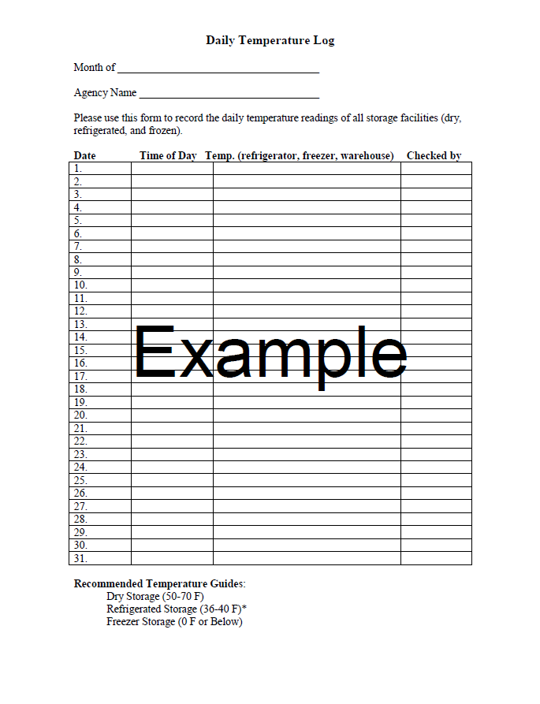

ANNEX 1-2a. Temperature Log example (electronic system)

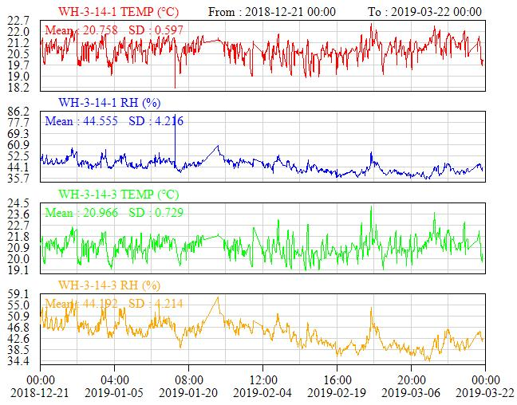

ANNEX 2 -11.a ERP traceability record example

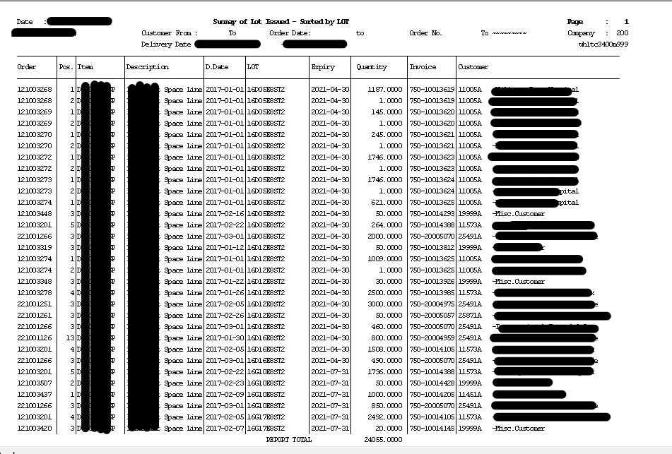

ANNEX 3 -17.a Decontamination Certificate
Decontamination Certificate - DCG
 |  | Stryker DECONTAMINATION CERTIFICATE
 |  | Stryker Ref No
CUSTOMER DETAILS
Organisation |  |  |  |  |  |  |  | Contact Name
Address |  |  |  |  |  |  |  | Position
 |  |  |  |  |  |  |  | Telephone No
 |  |  |  |  |  |  |  | Fax Number
Town |  |  |  |  |  |  |  | Post Code
City |  |  |  |  |  |  |  | Country
PRODUCT DETAILS
Product Code |  |  |  | Lot/Serial No |  |  | Qty | Product Code |  |  |  | Lot/Serial No |  |  | Qty
DECLARATION OF DECONTAMINATION STATUS
Please delete the responses that do not apply.
A | The product identified above has not been in contact with body fluids, tissues, respiratory gases, pathological samples or any other biological or chemical hazard
B | The product identified above has been fully cleaned and decontaminated in accordance with the manufacturer instructions. The method of decontamination was:
 | Note: Equipment must be disassembled and cleaned in accordance with the manufacturers instructions
C | 1) The product identified above has not been decontaminated or cleaned. ………………………….  2) Decontamination of the product is not possible because:
PRODUCT RETURN INSTRUCTIONS
1 | Approval - Do not return any contaminated product without prior approval from Stryker. Special arrangements will be made for the shipping of product that cannot be decontaminated
2 | Transport - Couriers and transport handlers must be informed of any shipments that contain contaminated or hazardous product. Do not use standard mail or courier service to return contaminated product.
3 | Packaging - Double package the product. Please do not use any staples or metal fasteners, which may cause injury or tear protective clothing on opening. When packaging contaminated product please use the special bio-safety containers.
4 | Labelling - All product must have the appropriate labels or reference numbers visible on at least two sides of the external package. Contaminated product must have the bio-safety label attached to at least two sides of the package
5 | Documentation - Copies of appropriate documentation must be returned with product decontamination certificate.  Documents must be secured to the outside of the package.
Please Note: Failure to comply with the above instructions contravenes Health and Safety and Shipping regulations. It may also comprise the health and safety of any persons coming into contact with the shipment. Stryker will not accept any liability whatsoever for harm or injury, which has been caused because of a failure to comply with appropriate regulations for the shipping of, contaminated and hazardous material. Stryker also reserves the right to take action against perpetrators to protect the health and safety of its employees and sub-contractors
Name of responsible: |  |  |  |  |  |  |  | Signed
Position |  |  |  |  |  |  |  | Date

Annex 4-20.a Product Complaint Form

Product Complaint Form
Intake
* | Consent to the personal data processing | By submitting this questionnaire to Stryker, I guarantee that all the data provided will be anonymized and will not contain my personal data, personal data of the patient(s) or personal data of the medical worker(s). This data is collected, processed, stored in order to control undesirable events associated with Stryker products. Actions with the provided data include recording, systematization, accumulation, storage, clarification (update, change), extraction, use, access of the organization's personnel, cross-border transfer, blocking, deletion, destruction of personal data.  ☐ I provide the consent for personal data processing
* | Country Of Event
* | Stryker Personnel

Event Details
* | Event Date | What date did the issue occur?
 | Approx | Pick Yes, if exact event date is unknown.
* | Event description | What was experienced? What happened? Was any replacement device used?
* | How was the issue Noticed? | Was this identified during, prior or after medical procedure/installation/in coming inspection/service, out of box failure?
* | Procedure completed successfully?
* | Patient Involvement? | Was the patient affected as a result of the event?
* | Medical Intervention? | Any unanticipated medical procedures/treatments/therapy administered in relation to the alleged event or device malfunction.
* | Surgical Delay | Any unanticipated delay or prolongation to any medical procedures/treatments/therapy?
* | Adverse Consequences | Any patient or user impact/affect
 | Death Date
* | User/Distribution Reported | Did the Initial Reporter Report this to a Regulatory Authority?

Contact Information
* | Initial Reporter Facility  (Stryker /third part distribution site) | If known, Enter Initial Reporter Facility name.
* | Initial Reporter Type
* | Initial Reporter Address
* | Initial Reporter City
 | Initial Reporter Postal Code
* | Initial Reporter Country
* | Initial Reporter Email:
* | Initial Reporter Phone
Contact Reporting Incident / Hospital name
(when Incident was reported by a Stryker third part distribution site)
Hospital Address
(when Incident was reported by a Stryker third part distribution site)
 | Health Professional Occupation | If health profession, list occupation.
Contact Information:Tel.#, Fax # , e-mail address
(when Incident was reported by a Stryker third part distribution site)

Product Details
- Product – long description:
Catalogue #
Lot/Serial #
Quantity
- Product – long description:
Catalogue #
Lot/Serial #
* | Complainant Require Results | Does complainant require investigation results?
* | Product Available To Stryker
* | Product Not Available, Why Not
 | Medical Records Available | Photos, X-Rays, Medical Files
 | Product to be Returned | Is Product to be returned to complainant?

Patient/Physician Info
Patient Identifier | For confidentiality purposes, list initials or other similar patient identifier.
Anatomy Position | Body part affected by event.
Gender
Age at time of event
Age Units (Patient)
Height
Height Units
Weight
Weight Units
Date of Birth
Date of Implant
Date of Explant
Activity – Post Implant | Describe patient activity post-surgery.
Revision | Indicate if implant event is about (or revision of) primary product, if not primary, what revision number.
Clinical Study Type
Clinical Study Description

