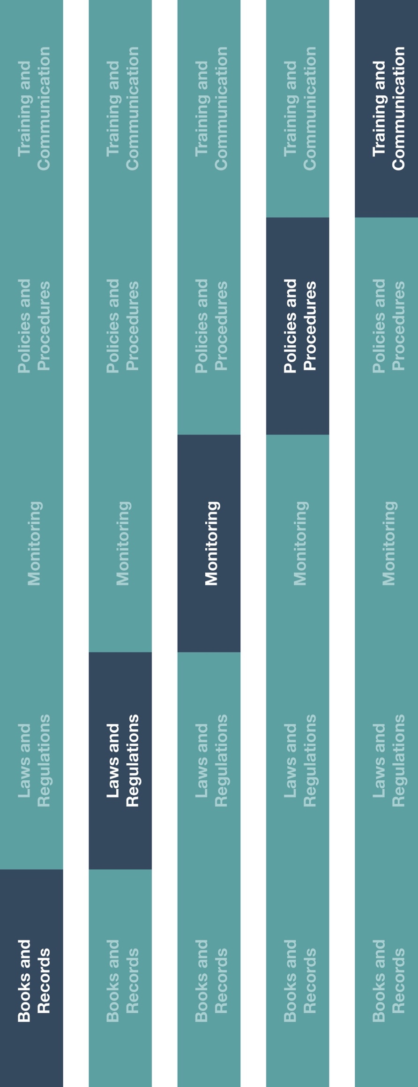

**Indirect Channel**

**Resource Center**

*Please consider all local industry code(s) (e.g., AdvaMed) and local laws when interacting with healthcare professionals or government officials



**Other documentation to consider**

* Code of Conduct
* HCP and Government Official Interactions Policy
* Commercial Pricing Policy

**How does this benefit you?**

This policy will provide employees with a better understanding of items that are considered free of charge and the criteria for providing these items. The policy explains differences between free of charge items and provides guidance to help your employees determine when free of charge items, with a legitimate business purpose, are appropriate.



|  |
| --- |
| **Description**  The Loaner, Sample & Demonstration Product Policy establishes guidelines for when it is acceptable to provide items free of charge to end customers. End customers could  Include, but are not limited to, sub-distributors/agents, healthcare professionals (HCPs)  and healthcare organizations. |



**Instructions**

1. Ensure all employees are aware of the Loaner, Sample & Demonstration Product Policy.
2. Ensure all employees are familiar with local laws and regulations regarding free of charge products including samples, evaluation products/equipment prior to providing them to HCPs.

**Loaner, Sample and Demonstration Product Policy**

*Version 1.0*

**LOANER, SAMPLE & dEMONSTRATION PRODUCT Policy**

**PURPOSE**

Providing items free of charge to end customers including loaner, sample and demonstration products can be appropriate in few circumstances. The information below can serve as guidance to help understand the differences between these items and when it is appropriate to provide them to end customers. End customers can include but are not limited to HCPs[1], HCO[2]s, and sub-distributors/agents.

**LOANER**

Items may be provided free of charge for various commercial reasons that may include replacement of missing/damaged items, replacement or repair due to breach of warranty, recall or other product quality issues. Temporary loaner equipment can also be provided while a product is being repaired if an appropriate agreement is in place.

**SAMPLE**

A sample is a small supply of a consumable product provided to HCPs in order for them to familiarize themselves and acquire experience in dealing with it. The purpose of a sample is to allow HCPs the opportunity to experience the product and to learn its effective and safe clinical use. We not expect to regain possession or ownership of samples as they are normally single-use products.

**DEMONSTRATION PRODUCT/EQUIPMENT**

Demonstration products/equipment are capital products or equipment provided free of charge to HCPs. The purpose of demonstration product/equipment is to help evaluate user-feedback over a defined period related to intended use of product/equipment. It is recommended this feedback period not exceed 90-days.

**ACCEPTABILITY AND REQUIREMENTS**

Items free of charge should only be provided when there is a legitimate business reason for doing so and the distribution of these items complies with applicable laws, regulations and practices. These items should enable the end customer to determine if it would like to purchase such products, but not improperly influence their decision. For example:

* **Loaners** should be provided only to help resolve a product quality issue and an appropriate agreement is in place.
* **Samples** should be provided only to allow end users to familiarize themselves with the product. The number of samples provided should be reasonable.
* **Evaluation products/equipment** can be provided to end users when there is a legitimate business purpose for a reasonably necessary time frame depending on the frequency of anticipated use.

A business representative should obtain required written approval before providing items free of charge items and in doing so, should define the appropriate business purpose and the duration associated with providing this item.

A written document with the end customer should be obtained. Please see *Documentation Requirements* table below for items that should be included within the written agreement.

1. Healthcare Professionals

   2 Healthcare Organizations
2. *The information contained in this document is not intended to be an absolute list. Please refer to local laws and regulations regarding items provided free of charge including samples, demos, and evaluation products/equipment.