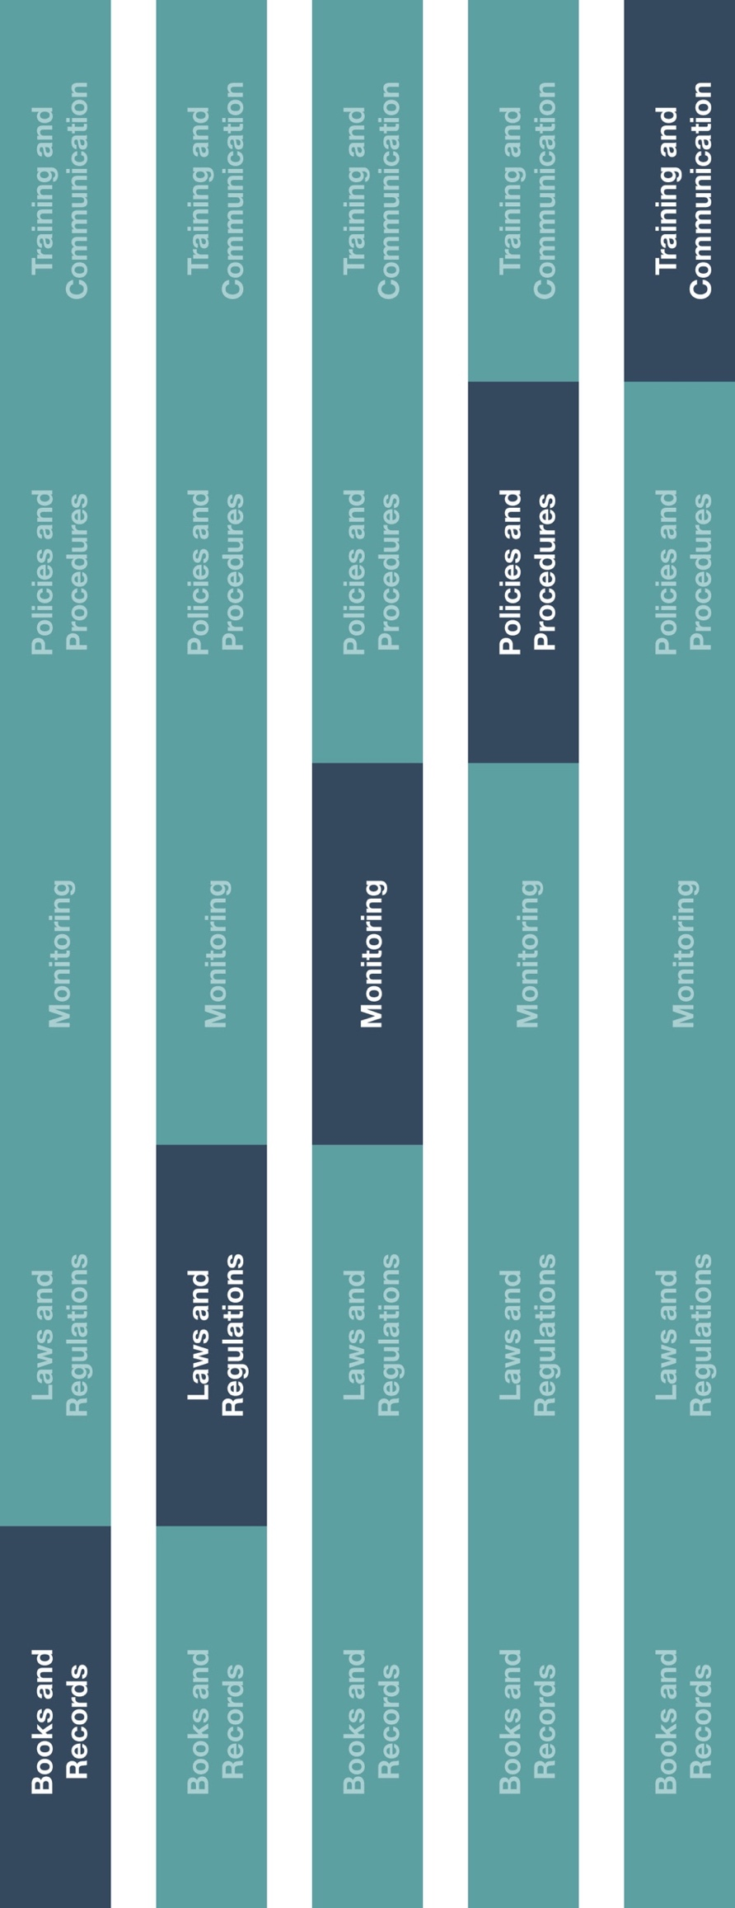



**Instructions**

1. Customize the highlighted sections of the HCP and Government Official Interactions Policy.
2. Provide the HCP and Government Official Interactions Policy to relevant employee(s).
3. Ensure employee(s) responsible for interacting with HCPs and government officials understand applicable guidelines.

**How does this benefit you?**

Establishing an HCP and government official interactions policy will help guide employees’ behavior when interacting with these individuals. This policy will also help ensure that your company complies with local laws and regulations surrounding these high risk interactions.



*Please consider all local industry code(s) (e.g., AdvaMed) and local laws when interacting with healthcare professionals or government officials



**Other documentation to consider**

* Code of Conduct
* HCP Employer Notification
* HCP Invitation Letter
* HCP Invoice Template

|  |
| --- |
| **Description**  The HCP and Government Official Interactions Policy establishes guidelines when  Interacting with healthcare professionals (HCP) and/or government officials and to help  ensure interactions are fair, honest and have a legitimate business purpose. |



**Indirect Channel**

**Resource Center**

*Version 1.0*

**HCP and Government Official Interactions Policy**

**HCP AND GOVERNMENT OFFICIAL INTERACTIONS POLICY**

**PURPOSE OF POLICY**

Interactions with HCPs and government officials are sensitive and highly regulated. It is our responsibility to ensure our interactions with HCPs and government officials, conducted on behalf of the Company, are done so in compliance with applicable laws and regulations. As a result, this policy includes general guidelines for interactions with HCPs and government officials to help determine if certain interactions are appropriate.

**GENERAL GUIDELINES**

* All communication and direct interactions with HCPs and government officials must have a legitimate business purpose.
* All expenses paid for on behalf of HCPs and government officials should be reasonable in nature with no intention of unlawful inducement or encouragement to purchase, lease or recommend the use of any product or service.
* Nothing of value is provided to spouses, guests or employees of HCPs and government officials or any other person without a bona fide professional interest.
* Entertainment or recreational activities for HCPs and government officials are not permitted.
* Obtain pre-approval, when necessary, prior to engaging with HCPs and government officials and document interactions in accordance with all transparency[1] and books and records requirements.

**TRAVEL for HCPs and government officials may be appropriate if all of the following are met:**

* There is a legitimate business reason or need.
* Travel arrangements do not cover a period reasonably beyond the event (i.e. more than 24 hours before or after the event).
* Economy class travel is the default choice for all HCP and government official travel.
* HCPs and government officials should not be compensated for upgrade costs or travel time and only at a fair market value

**LODGING for HCPs and government officials may be appropriate if all of the following are met:**

* There is a legitimate business reason need.
* Location is selected based upon event location, location of attendees and cost.
* Lodging rates are reasonable and modest when compared to other local standard rates.

**MEALS for HCPs and government officials may be appropriate if all of the following are met:**

* There is a legitimate business reason or need.
* The meal is provided in conjunction with a training and education event.
* Meals are provided occasionally and are not intended to influence business decisions.
* The meal is reasonable, modest, take place at an appropriate location and fall within our designated meal limits:

|  |  |  |
| --- | --- | --- |
| **Breakfast: [insert amount]** | **Lunch: [insert amount]** | **Dinner: [insert amount]** |

**CONSULTING ARRANGEMENTS with** **HCPs and government officials may be appropriate if all of the following are met:**

* There is a legitimate business need and the selection is based on their expertise.
* Compensation HCPs and government officials should reflect the fair market value of the work performed.
* Proper approval is received from the applicable employer and affiliated local institutions when necessary.
* Selection was not made in an attempt to influence the sale of products.

1. Transparency laws are legal reporting requirements relating to the provision of anything of value to an HCP. It is our responsibility to ensure our interactions with HCPs are conducted in compliance with all applicable laws, regulations, government guidance and high ethical standards.