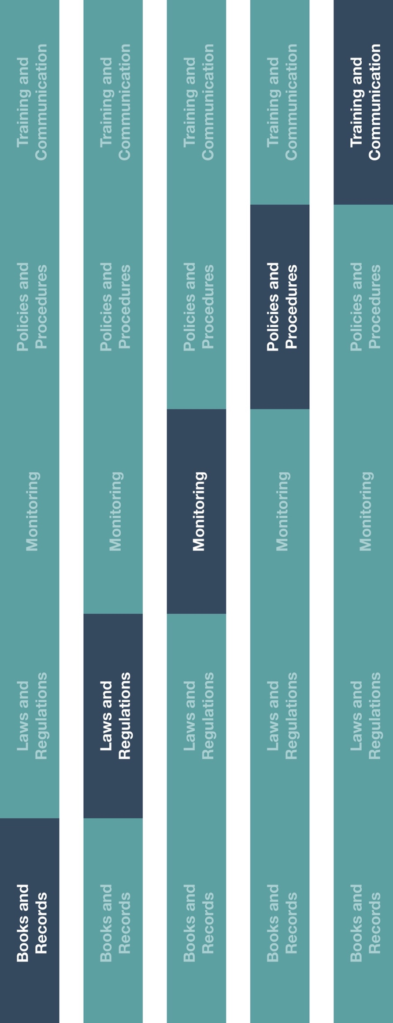

**Indirect Channel**

**Resource Center**



**Instructions**

1. Ensure employee(s) are aware the HCP Invoice Template and your company’s guidance on maintaining records.
2. Provide the HCP Invoice Template to employee(s) responsible for engaging/interacting with HCP consultants and employee(s) responsible for approving/making payments to HCP consultants.
3. HCP Consultants should complete the invoice and submit it for payment along with all supporting documentation.



**Other documentation to consider**

* HCP and Government Official Interaction Guidance
* Books and Records Guidance

**How does this benefit you?**

Keeping a record of HCP invoices will help ensure compliance with HCP-related policies and procedures. It will also ensure your books and records accurately and fairly reflect your company’s transactions in reasonable detail and enable you to meet reporting requirements, if any, within your country/region.

Consulting contracts and related payments must not be provided as an unlawful inducement or encouragement to purchase, lease or recommend the use of any product or service.



|  |
| --- |
| **Description**  Healthcare professional (HCP) consultants should provide a detailed invoice to you for services provided by the HCP as per the written contract with the HCP. The HCP Invoice Template describes supporting documentation required for payments made to HCPs related to consulting services, speaking arrangements, trainings and/or other educational events. |



**HCP Invoice Template**

*Version 1.0*

|  |
| --- |
| **HCP Invoice Template** |
| Bill to:                                                                        Date: |

|  |  |  |  |  |
| --- | --- | --- | --- | --- |
| **Date of Service(s)** | **Detailed Description of Services** | **Hourly Rate** | **Total Hours** | **Total**  **(without tax)** |
|  |  |  |  |  |
|  |  |  |  |  |
|  |  |  |  |  |
|  |  |  |  |  |
|  |  |  |  |  |
|  |  |  |  |  |

Subtotal: _____________

Tax: _____________

Grand total: _____________

Name of HCP: __________________________________________

Tax identification number: _________________________________

___________________________________

*HCP Signature*

*Enclosed please find supporting documents