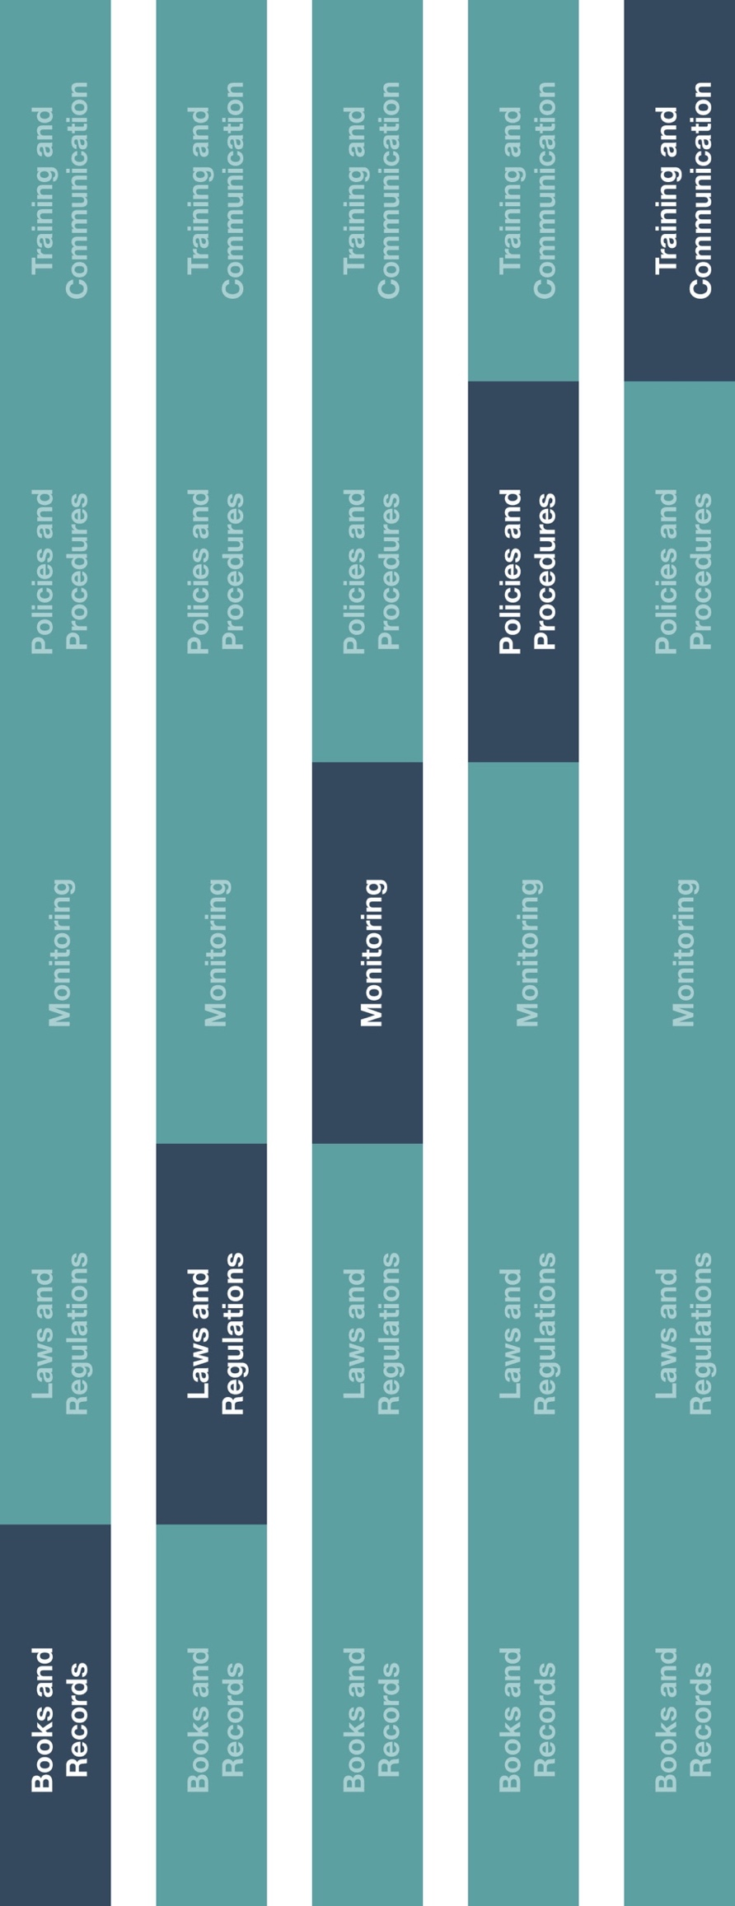

**Indirect Channel**

**Resource Center**

*Please consider all local industry code(s) (e.g., AdvaMed) and local laws when interacting with healthcare professionals or government officials



**Instructions**

1. Customize the highlighted sections of the HCP Invitation Letter.
2. Adjust to reflect local laws, industry codes or any other applicable details, as required.
3. Provide the HCP invitation letter to employee(s) responsible for keeping records related to HCP events.
4. Ensure relevant employee(s) are aware of the HCP Invitation Letter and your company’s guidance on maintaining records.



**Other documentation to consider**

* HCP and Government Official Interactions Policy
* HCP Employer Notification

**How does this benefit you?**

Keeping record of invitation letters sent to HCPs encourages transparency in your company’s interactions with HCPs and promotes good documentation practices.

Invitations to trainings and/or other educational events must not be provided as an unlawful inducement or encouragement to purchase, lease or recommend the use of any product or service.



|  |
| --- |
| **Description**  Distributors/agents should keep a record of invitation letters sent to healthcare professionals (HCPs) to attend trainings and/or other educational events hosted by a manufacturer or your company. |



**HCP Invitation Letter**

*Version 1.0*

# **HCP INVITATION LETTER**

**[date]**

**[name]**

**[address]**

*Re: Invitation to* **[event name]**

Dear **[name],**

On behalf of **[company name**], we would like to invite you to attend the **[event name]** taking place at the **[venue name, location]** in **[city, country]** on **[date]** (the “Meeting”).

Course objectives include the following: **[add educational objective of the course]**

If you accept our invitation, we would provide you with the following, if applicable:

* Accommodation in a single room at the **[hotel name]** for **[number of nights]** nights from **[date]** to **[date]**.
* Airfare to and from the Meeting economy class.
* Reasonable food & beverage at the Meeting for the days on which the Meeting is held.

Please note that this event is for HCPs only and guests and spouses are not allowed at this event. In addition, we are unable to pay for or facilitate the payment or arrangement for any costs incurred for personal travel or for your spouse or guest and any changes to your travel itinerary should be previously approved by **[company name]**.

By participating in the Meeting, you agree to comply with applicable local and international laws (including, but not limited to, the United States Foreign Corrupt Practices Act), local anti-bribery anti-corruption laws and professional code and standards, per our company’s Code of Conduct that you are familiar with such laws, codes and standards. The funding offered in this letter is not conditioned on any implicit or explicit agreement by you to purchase, recommend or influence the purchase of our products.

Your employer may require that it be notified of or consent to the support offered in this letter. If so, please notify us in writing and include the details of your employer’s name and address so that we can send the notification.

This letter sets forth the entire agreement between you and **[company name]** with respect to the Meeting, and has priority over all other related documents, verbal discussions and/or understandings between you and **[company name].** This invitation is contingent upon your compliance with the terms and conditions set forth in this letter and attendance at the event.[1]

Best regards,

________________________ _____________________

**[name, position]** [**HCP signature**]

1. Please consider all local data privacy laws