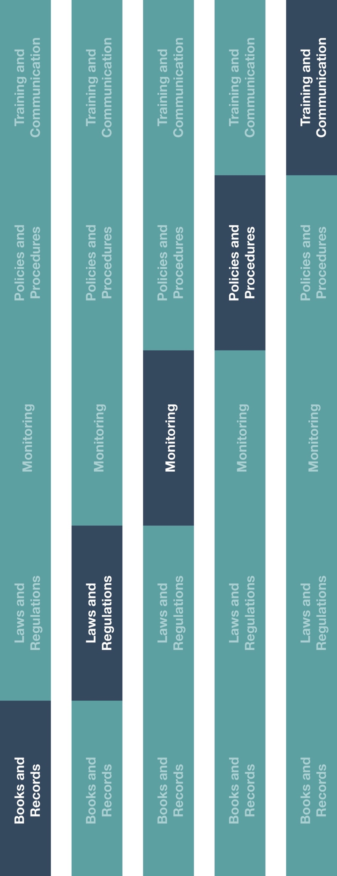

**Indirect Channel**

**Resource Center**



**Instructions**

1. Customize the highlighted sections of the HCP Employer Notification template.
2. Adjust to reflect local laws, industry codes, or any other applicable details, as required. It is recommended that proof of delivery of this notification is documented.
3. Provide the HCP Employer Notification to employee(s) responsible for keeping records related to HCP engagements.
4. Ensure relevant employee(s) are aware of the HCP Employer Notification and your company’s guidance on maintaining such records.

|  |
| --- |
| **Description**  Prior to engaging a healthcare professional (HCP) and if required by the HCPs  employer and/or local laws, distributors/agents should notify the employer and obtain  their approval for the prospective engagement. |



**Other documentation to consider**

* HCP and Government Official Interactions Guidance
* HCP Invitation Letter

**How does this benefit you?**

Keeping record of HCP employer notifications and approvals will help provide reasonable, transparent details and documentation related to HCP engagements. It will also ensure your books and records accurately and fairly reflect your company’s transactions in reasonable detail and enable you to meet reporting requirements, if any, within your region/country.

Invitations to trainings and/or other educational events must not be provided as an unlawful inducement or encouragement to purchase, lease or recommend the use of any product or service.



**HCP Employer Notification**

*Version 1.0*

# **HCP EMPLOYER NOTIFICATION**

**[date]**

**[name of HCP’s employer]**

**[address of HCP’s employer]**

Dear **[insert name of HCP’s employer],**

**[insert company name]** is requesting the **[attendance/appointment]** of **[insert HCP’s name]** as a **[speaker/consultant]** at **[insert event name].**

As a **[speaker/consultant],** they will be expected to participate in **[insert event details including name of event, event organizer and event location including country, and purpose of event/insert details regarding the consulting arrangement].** This **[event/appointment]** is related to **[insert HCP’s name]’s** professional skills and will help advance medical knowledge.

This invitation is not intended to improperly influence in any way the decisions of an HCP regarding the use of medical products. All expenses paid on the HCP’s behalf will be strictly related to the educational event and period outlined above.

Please contact us by **[insert date]** if you have any concerns via email at **[email address]** or via phone at **[phone #].**

Best regards,

**[name]**

**[title]**

**[company name]**