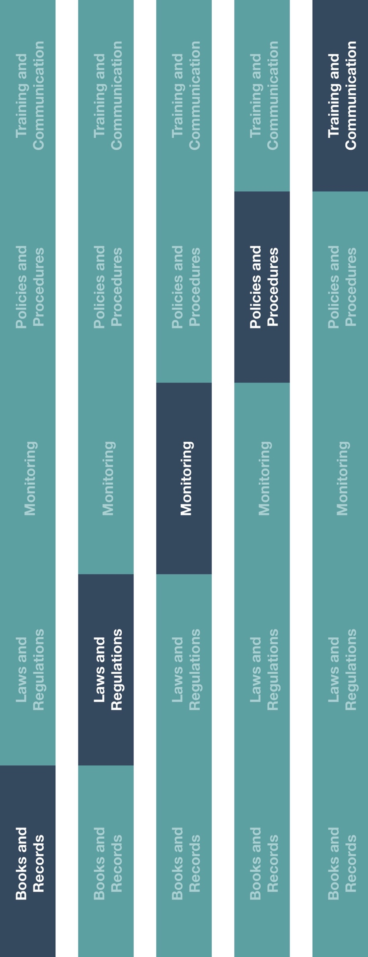

**Indirect Channel**

**Resource Center**

|  |
| --- |
| **Description**  The Travel and Expense Policy outlines processes to ensure company travel,  entertainment and other out-of-pocket expenses have a clearly documented business  purpose, are supported by adequate supporting documentation and conform with both company and manufacturer expectations.  Please note this policy pertains to travel, entertainment and other out-of-pocket expenses incurred by employees. For interactions with HCPs or government officials, utilize the  HCP and Government Official Interactions Policy. |



**Other documentation to consider**

* Code of Conduct
* HCP and Government Official Interactions Policy
* Expense Report Form
* Gift Log
* Gift Recipient Confirmation
* Petty Cash Guidance



**Instructions**

1. Customize the highlighted sections of the Travel and Expense Policy.
2. Provide the Travel and Expense Policy to all employees.
3. Provide specific training to employee(s) responsible for approving and reimbursing expenses to ensure their understanding of the Expense Reimbursement Form, reimbursement guidelines and procedures (including required documentation & relevant spending limits).

**How does this benefit you?**

This policy will help ensure that your company incurs and reimburses only legitimate business costs that are related to a legitimate business interest. This policy also provides guidance to employees about their responsibilities related to travel, entertainment and other out-of-pocket expenses.



*Please consider all local industry code(s) (e.g., AdvaMed) and local laws when interacting with healthcare professionals or government officials

**Travel and Expense Policy**

*Version 1.0*

**TRAVEL AND EXPENSE POLICY**

**POLICY STATEMENT**

This policy provides requirements to follow when submitting, reviewing and approving reimbursements for employee business travel, entertainment and other out-of-pocket expenses. If employees do not comply with the Travel and Expense Policy, they may be subject to delay or withholding of reimbursement and/or disciplinary action. Travel related and other expenses should never be used to improperly influence a decision or action of any third-party. Refer to the Code of Conduct for additional information. Additionally, when conducting business with healthcare professionals (“HCPs”) and government officials, additional guidance or procedures may be necessary. For these interactions, reference the HCP and Government Official Interactions Policy.

**PURPOSE**

This policy provides guidance for employees regarding what travel, entertainment and other out-of-pocket expenses are reimbursable and explains their responsibilities related to submitting expenses for reimbursement. This policy also helps ensure travel, entertainment and other out-of-pocket expenses submitted for reimbursement have a legitimate business purpose, adequate supporting documentation.

**GUIDELINES**

* Personal expenses (e.g. related to family member travel) are never reimbursable.
* To the extent possible, travel (e.g., airfare) should be purchased in advance to minimize costs.
* More affordable options should be utilized when possible (e.g., cheaper flights landing within similar timeframe or a cheaper flight to a similarly local airport).
* All expenses should be approved through established internal approval processes.
* To the extent petty cash is used for any travel or entertainment expenses, please refer to Petty Cash Guidance.
* Advances to employees must be preapproved through established internal approval processes.

**DOCUMENTATION REQUIREMENTS**

* All business and entertainment expenses should be clearly documented in an Expense Report Form with a clear business purpose.
* Employees should maintain all relevant documentation (e.g., invoices, approvals, attendee lists) and should provide this information with their expense reimbursement request.
* Receipts or invoices must be submitted for all expenses.
* Additional supporting documentation for travel expenses should include:
  1. Copies of receipts including an itemized receipt and a copy of the credit card receipt.
  2. The number of attendees and their names (including entity/hospital affiliation).
  3. Transparent business purpose for the travel (e.g. what product was discussed).

**EXPENSE REPORT SUBMISSION AND APPROVAL PROCEDURE**

1. Employees should obtain pre-approval before incurring travel expenses exceeding **[insert threshold amount and currency]**. All entertainment expenses must be pre-approved through established internal approval processes.
2. Expense reports and reimbursement requests should be submitted through the appropriate internal processes within **[insert number of days (e.g., 30)]**, ensuring all appropriate documentation has been included.
3. The approver should:
   1. Ensure that the travel, entertainment and all other out-of-pocket expenses submitted are reasonable, necessary and, if required, pre-approved.
   2. Ensure the expenses have a clear and documented business purpose.
   3. Ensure appropriate prior approval has been received (when necessary).
   4. Approve and submit the expense for reimbursement in a timely manner.

**EXPENSE TYPE RULES AND RESTRICTIONS**

**Meals and Lodging Expense:**

* Meals - Employees traveling on Company business may expense reasonable and modest meals that fall within the local meal limit. Meals should also be held at an appropriate venue. Limits by meal are as follows:

|  |  |
| --- | --- |
| **Meals with non-HCPs:** | **Meals *with HCPs:*** |
| Breakfast: **[insert local limit and currency]** | Breakfast: **[insert local limit and currency]** |
| Lunch: **[insert local limit and currency]** | Lunch: **[insert local limit and currency]** |
| Dinner: **[insert local limit and currency]** | Dinner: **[insert local limit and currency]** |

* Lodging - Lodging rates should be reasonable and modest when compared to other standard local rates. Lodging rates should not exceed **[insert local limit and currency]** per night.

**Travel and Transportation Expenses:**

* Air Travel - Employees are required to fly coach/economy class for local or national travel. Business class airfare is allowable for international flights exceeding **[insert hours]**, with **[Insert role]** pre-approval.
* Public Transportation (including trains) - Public transportation, including buses and trains, should be utilized for ground travel to the extent possible when this method is the most economical for the employee’s needs. Long-distance train travel should be booked in coach/economy class.
* Taxis (including rideshare services) - The use of taxis or rideshare services should be considered if employees expect this to be the most economical type of travel for their needs.
* Car Rentals & Personal Automobiles - Car rentals should be used only when other alternatives are not available. Personal automobile mileage reimbursement should be consistent with local country guidelines.

**Gifts**

Gifts should never be provided as an unlawful inducement or encouragement to purchase, lease or recommend the use of any Company product or service. Employees are not allowed to accept gifts from third-parties above the nominal amount of **[insert dollar value and local currency type].** Conversely, any gifts provided to a third-party exceeding **[insert dollar value and local currency type]** require approval from **[insert approver]**. Employees should utilize the Gift Recipient Confirmation and Gift Log when receiving or providing gifts.