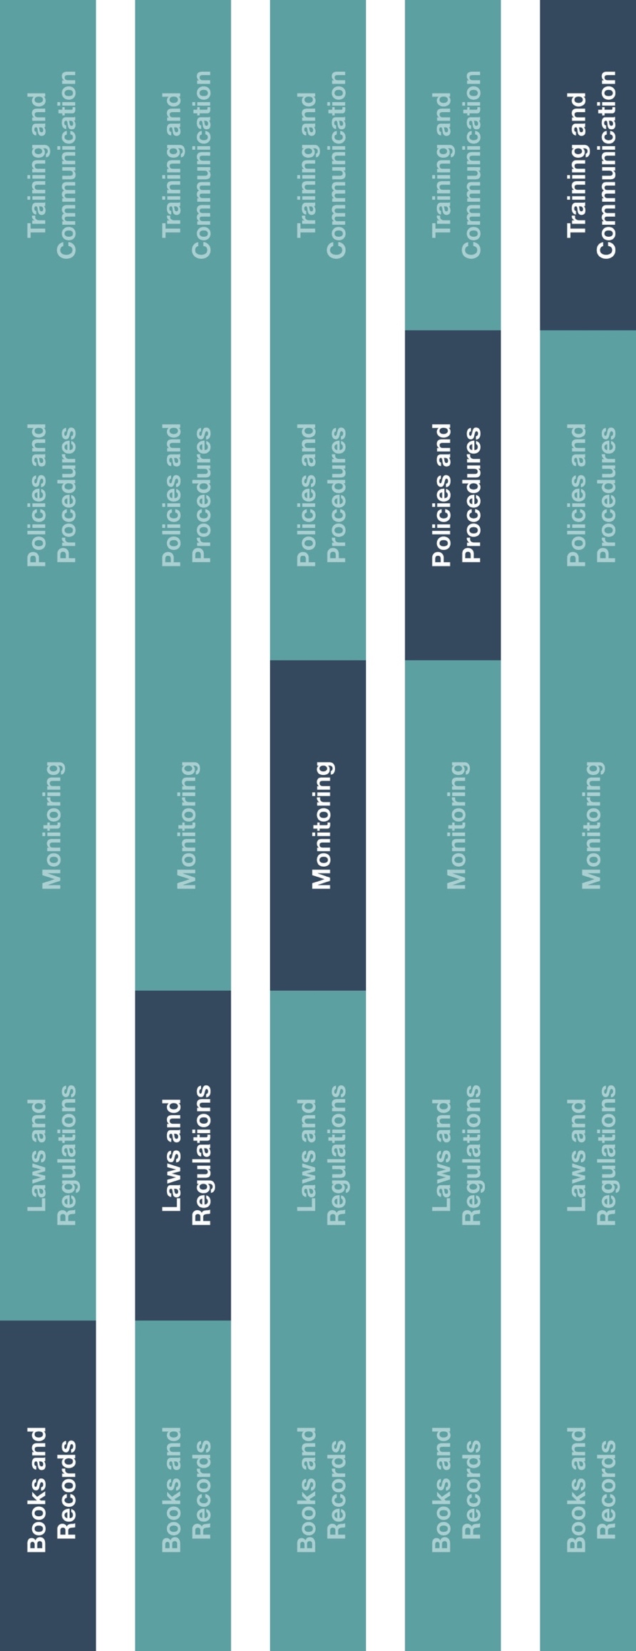

**Indirect Channel**

**Resource Center**



**Other documentation to consider**

* Sub-Distributor/Agent Appointment Procedure



**Instructions**

1. Review this guidance prior to executing any new sub-distributor/agent contracts or written agreements.
2. Execute a written agreement with all new sub-distributors/agents and include the clauses and provisions provided.
3. For existing sub-distributor/agent relationships, an agreement should be executed with any sub-distributor/agent not covered under one already.
4. Review your sub-distributor/agent agreements with your manufacturers to identify any manufacturer-specific requirements or contract terms.

**How does this benefit you?**

This guidance will help ensure that the risks associated with your sub-distributors/agents sales and service activities are mitigated by incorporating certain components and provisions into written agreements and contracts.



|  |
| --- |
| **Description**  The Sub-Distributor/Agent Contract Guidance provides recommendations and leading  practices for contracting with sub-distributors/agents involved in the sales or service  of products to your end-customers. |



*Version 1.0*

**Sub-Distributor/Agent Contract Guidance**

**SUB-DISTRIBUTOR/AGENT CONTRACT GUIDANCE**

Written agreements are an important tool for mitigating risks posed by sub-distributors/agents. Utilize this guidance to understand what components should be included

**WHEN IS A CONTRACT NEEDED?**

A contract should be executed with every sub-distributor/agent that we will appoint. If a potential sub-distributor/agent refuses to enter into a written agreement, you should reconsider the suitability of that entity as a business partner.

**WHAT ELSE DO I NEED TO DO?**

Before executing a contract with a sub-distributor/agent, you should consult with each of our manufacturers to identify any required contract provisions to be included within sub-distributor/agent agreements, but, at a minimum, you should:

* Notify each manufacturer for which the potential sub-distributor/agent will provide services (and, if required, receive their approval).
* Complete due diligence on the potential sub-distributor/agent (if due diligence will not be performed by the manufacturer(s)).
* Provide training to the potential sub-distributor/agent on our business and compliance expectations.

**WHAT COMPONENTS SHOULD BE IN THE CONTRACT?**

Our contract should describe the relationship and scope of services in as much detail as possible and at a minimum, include the following:

* The legal name of each contracting party.
* Responsibilities of each contracting party.
* How the sub-distributor/agent be compensated for any services performed (e.g., commission, fix fees).
* The term of the contractual agreement.
* Available remedies in the event either party fails to meet its obligations.

**WHAT COMPLIANCE TERMS AND CONDITIONS SHOULD BE INCLUDED?**

The following conditions will help protect us from the elevated risks associated with sub-distributors/agents and should be included in our contracts:

* A provision requiring the sub-distributor/agent to abide by all applicable laws and regulations, including international laws to which you may be committed to under your distribution/agent agreements with manufacturers, such as the U.S. Foreign Corrupt Practices Act.
* A provision certifying that the sub-distributor/agent will follow our Code of Conduct, our manufacturers’ Codes of Conduct and any other appropriate policies and procedures.
* A provision allowing for termination of the contact if any clause is breached.
* A provision allowing us to examine or audit the books and records of the sub-distributor/agent to assess compliance with the contract.
* A provision requiring the sub-distributor/agent to provide Anti-bribery Anti-corruption training to all employees that will be engaged in providing services to us or our manufacturers.

*Note: Consult with your legal advisors prior to entering into any contractual arrangement with any third-party.*