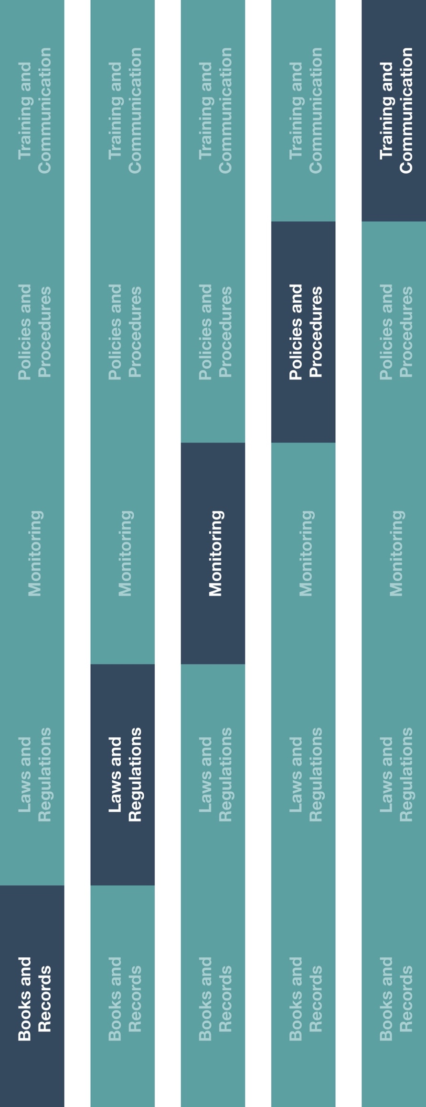

**Indirect Channel**

**Resource Center**

**How does this benefit you?**

This procedure can protect your business by ensuring that the risks associated with your sub-distributors/agents are mitigated through defined controls and processes for identifying, appointing and maintaining your sub-distributor/agent relationships.



**Other documentation to consider**

* Sub-Distributor/Agent Contract Guidance
* Commercial Pricing Policy



**Instructions**

1. Customize the highlighted sections of the Sub-Distributor/Agent Appointment Procedure
2. Apply this procedure when appointing any new, or renewing old, sub-distributors/agents.
3. Communicate this procedure to relevant employee(s), specifically those who identify new sub-distributors/agents, manage sub-distributor/agent relationships and/or are responsible for approving sales and/or payments to sub-distributors/agents,
4. Provide training to these employees on how this procedure will be implemented and executed going forward.

|  |
| --- |
| **Description**  The Sub-Distributor/Agent Appointment Procedure provides instructions to implement  controls to mitigate risks related to your sub-distributors/agents.  Please note, Sub-ICs may or may not take title to the inventory prior to final sale. |



*Version 1.0*

**Sub-Distributor/Agent Appointment Procedure**

**SUB-DISTRIBUTOR/AGENT APPOINTMENT PROCEDURE**

Defined third-party controls and processes are critical tools to mitigate the risk that our sub-distributors/agents may pose to the Company. The steps below must be applied to each sub-distributor/agent that the Company appoints.

**SUB-DISTRIBUOR/AGENT DEFINITION**

As a **[distributor/sales agent]** for manufacturers of healthcare products, any third-parties that purchase those products for resale or assist in the sale of those products to customers are considered sub-distributors/agents. The procedure laid out below must be completed for each and every sub-distributor/agent with which our Company does business.

The procedure does not cover controls and processes related to other types of third-parties that provide goods or services to the Company (e.g., customs brokers, travel agents, consultants). For guidance related to those parties, refer to the High Risk Third-Party Vendor/Supplier Appointment Procedure.

**DUE DILIGENCE, CONTRACTING AND APPOINTMENT**

Prior to any sub-distributor/agent being appointed, the following steps must be completed:

1. **Due Diligence**: Once a sub-distributor/agent is identified as a potential business partner, due diligence must be conducted on the individual or entity. Evidence of due diligence completion must be maintained by **[insert department name]**. These sub-distributor/agent due diligence procedures, whether conducted by a Company employee or designated service provider, must include:
   1. Documentation of the business need for, and qualifications of, the sub-distributor/agent.
   2. Perform background searches, reputational and adverse media check using internet, legal entity registration, beneficial owner confirmation and credit check.
2. **Contracting**: A valid, legal contract or written agreement must be executed between the Company and each sub-distributor/agent prior to any related sales transactions. The contract must;
3. Be signed on behalf of the Company by the **[insert role]**.
4. Clearly define the contracting entities, products within scope for the sub-distributor/agent arrangement, services to be provided by the sub-distributor/agent (including all after-sales and technical support services to be provided to any customer) and contract term.
5. Reflect any relevant commission rates, incentives or service fees.
6. How product prices will be set, if the sub-distributor/agent will purchase products from the Company.
7. Include Anti-bribery Anti-corruption (ABAC) terms and conditions. Refer to the Sub-Distributor/Agent Contract Guidance for additional contracting instructions.
8. **Appointment:** After due diligence and contracting is complete, the sub-distributor/agent may be fully onboarded. The sub-distributor/agent’s name, address, banking information, due diligence documentation and executed contract should be provided to the responsible employee(s) to activate the new sub-distributor/agent.

**PRICING, PAYMENTS, EVALUATION AND TERMINATION**

1. **Pricing**: Sales prices for products sold to sub-distributors/agents must be based on an analysis of cost, desired revenues and margins, potential future opportunities and other tangible factors, such as government price lists. After setting standard prices for a sub-distributor/agent, this analysis must be documented and approved by the **[insert role]**. Any special pricing, discounts or substantive deviations (defined as a price change of greater than **[define percentage]**) from this pricing must be approved by the **[insert role]**. Refer to the Commercial Pricing Policy for additional information and procedure.
2. **Payments**: Payment to sub-distributors/agents should be scrutinized more than payments to other third-parties. Prior to approving any payment to a sub-distributor/agent, all relevant documentation (including invoice, supporting documents evidencing the services provided (e.g., sales information used to calculate commission amounts) and payment request) must be reviewed by the **[insert role]**. Only after documenting the approvals of these individuals in writing may the payment be issued. Payments should only be issued directly to the individual or entity reflected in the sub-distributor/agent contract.
3. **Evaluation**: All sub-distributors/agents should be evaluated at least **[insert time period]** to ensure that i) the sub-distributor/agent is meeting the Company’s business and compliance expectations, ii) sales targets or objectives are met (and if not, why); iii) their services are still needed by the Company and iv) there have not been any significant changes that would affect the result of the initial due diligence conducted (e.g., change in ownership structure). Specifically, at the time of evaluation:
   * 1. The employee(s) that manage the relationship with the sub-distributor/agent should document in writing whether the sub-distributor/agent has achieved its objectives and targets and whether this sub-distributor/agent is still needed by the Company.
     2. The **[insert role]** should determine, through research and knowledge of the sub-distributor/agent, or discussions with the responsible employee(s), whether any events have occurred that would necessitate a refresh of previous due diligence conducted (e.g., a change in beneficial ownership of the sub-distributor/agent).
4. **Termination**: At the time of sub-distributor/agent termination:
   * 1. Develop a plan for the termination and disposition of any remaining inventory held by the sub-distributor/agent.
     2. Notify the sub-distributor/agent and associated manufacturer(s).
     3. Deactivate the sub-distributor/agent (i.e., sales and payment hold).
     4. Resolve any pending contractual obligations with end customers or other parties impacted by the termination.

The following circumstances (among others) may, at the discretion of the **[insert role]**, require termination:

* Breach of contract clauses, including ABAC terms and conditions.
* Knowledge of reputational issues or adverse media.
* Underperformance or missed targets/objectives.
* Judgment that the sub-distributor/agent’s services are no longer required.

**QUESTIONS AND CONCERNS**

Should you have questions on how to apply the procedure contained herein or any concerns about any sub-distributor/agent, you should raise these to your supervisor or **[insert role]** immediately.