1. 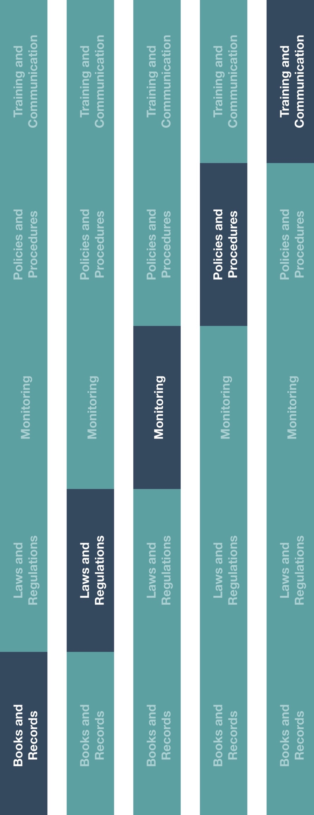

**Indirect Channel**

**Resource Center**

|  |
| --- |
| **Description**  Account reconciliation is an important component of maintaining accurate books and records. Distributors/agents should appropriately document the reconciliation of business-related petty cash disbursements.  Please note, the use of petty cash is not recommended, especially for high risk transactions (e.g., involving government officials, healthcare professionals, etc.) when alternative methods of payment are available. |



**Other documentation to consider**

* Petty Cash Voucher
* Petty Cash Guidance



**Instructions**

1. Provide the Petty Cash Reconciliation form to your employee(s) responsible for approving and reconciling petty cash transactions (e.g., custodians). Please ensure the voucher numbering system is in accordance with your company policy.
2. Follow your company’s process for reconciling petty cash transactions and payments.

**How does this benefit you?**

Documenting petty cash payment reconciliations will help ensure that books and records accurately and fairly reflect your company’s transactions in reasonable detail and help maintain an adequate system of internal accounting controls. Reconciling accounts will ensure you can identify any discrepancies and potentially inaccuracies in your books and records



**Petty Cash Reconciliation**

*Version 1.0*

**PETTY CASH RECONCILIATION**

|  |  |  |
| --- | --- | --- |
| **Petty Cash Reconciliation** | | |
| Complete the information below, attach all original receipts, supporting documentation and provide the approved petty cash voucher to the employee(s) responsible for keeping records of petty cash. | | |
| Voucher number(s): | | |
| Requested by:                                                                    Date: | | |
| Total Amount and Currency: | Unused Amount and Currency  (if any): | **Total (1 and 2) [1]** |
|  |  |  |
| Petty Cash Custodian: *I confirm the receipt of this form and any remaining funds.* | | |
| Approved by: Date: | | |

1. The total should equal the total amount disbursed in the reconciled Petty Cash Voucher(s).