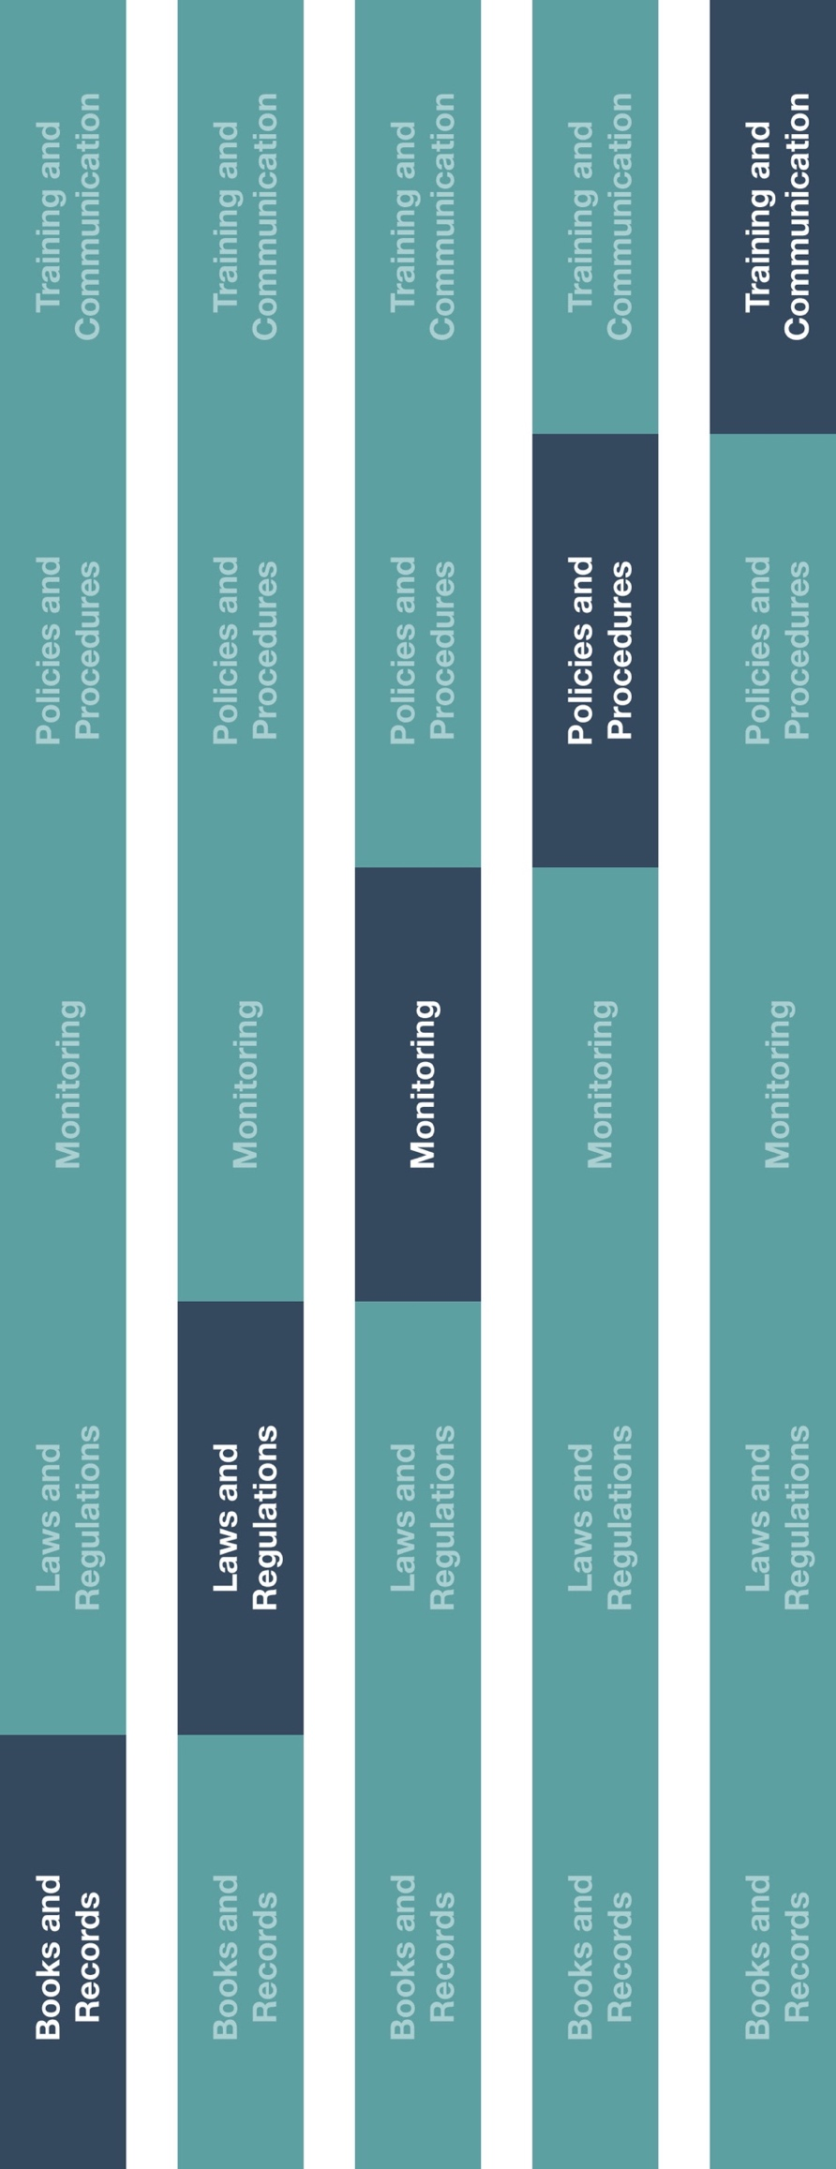

**Indirect Channel**

**Resource Center**

*Please consider all local industry code(s) (e.g., AdvaMed) and local laws when interacting with healthcare professionals or government officials



**Other documentation to consider**

* Petty Cash Reconciliation
* Petty Cash Voucher

|  |
| --- |
| **Description**  The Petty Cash Guidance establishes guidance for when it is appropriate to use petty case to pay for business related expenses.  Please note, the use of petty cash is not recommended, especially for high risk transactions (e.g., transactions involving government officials, healthcare professionals, etc.). |



**Instructions**

# Provide the Petty Cash Guidance to relevant employee(s) and ensure they understand what is considered appropriate petty cash use.

# Ensure petty cash custodians are aware of disbursement procedures including approval and supporting documentation requirements.

# Ensure petty cash is periodically monitored and reconciled.

**How does this benefit you?**

Petty cash transactions are high risk due to its susceptibility to theft or misuse and the lack of visibility and documentation related to the transfer of funds. The Petty Cash Guidance will help ensure your company’s petty cash is used for a legitimate business purpose and adequately documented.



*Version 1.0*

**Petty Cash Guidance**

**PETTY CASH GUIDANCE**

Petty cash funds are nominal amounts of physical cash made available for the purchase of miscellaneous and incidental items of small value. Petty cash should only be used when no other payment methods are available. The use of petty cash is not recommended, especially for transactions involving government officials, healthcare professionals, etc.

**EXAMPLES OF APPROPRIATE USES FOR PETTY CASH\***

* To pay for small out-of-pocket expense (e.g. tea or coffee).
* To purchase low value office supplies.
* To pay for local transportation.

**EXAMPLES OF WHEN PETTY CASH FUND SHOULD NOT BE USED**\*[1]

* To pay operating expenses (e.g. salaries, supplier invoices).
* To pay for work-related travel or entertainment expenses.
* To pay a personal debt.
* To pay for consulting services.
* To make any payments related to a contract.
* To pay dues and/or membership fees.
* To loan any sum of money to pay government agencies and/or officials.

**LEADING PRACTICES FOR PETTY CASH FUNDS**

* The petty cash fund amount should be limited to the lowest amount possible to meet expected needs as outlined above. The fund should be periodically assessed for the appropriateness of the fund amount and replenished when necessary.
* An employee should be designated as a custodian who is solely in charge of disbursing and documenting disbursements from petty cash funds on the Petty Cash Voucher.
* A separate, independent employee should be in charge of replenishing the petty cash fund to the necessary amount and reconciling disbursements using the Petty Cash Reconciliation.

**PROCEDURE**

1. Employees requesting reimbursement should fill out the Petty Cash Voucher and submit for approval from the petty cash custodian.
2. The petty cash custodian should review the Petty Cash Voucher and all relevant supporting documentation and reconcile the amount disbursed to the amounts paid.[2]
3. The petty cash custodian should disburse the funds in accordance with the approved Petty Cash Voucher.
4. Employees should submit the Petty Cash Voucher, receipts and return the excess cash to the petty cash custodian.

1. For any exceptions, which include payments to government agencies or officials, please use the Petty Cash Voucher to document the request and approval for petty cash.
2. When possible, this step should be performed by an independent party.

   * Examples noted above are **NOT** comprehensive lists of all eligible and ineligible petty cash expenditures. Discretion should be used when determining appropriate use of petty cash funds.