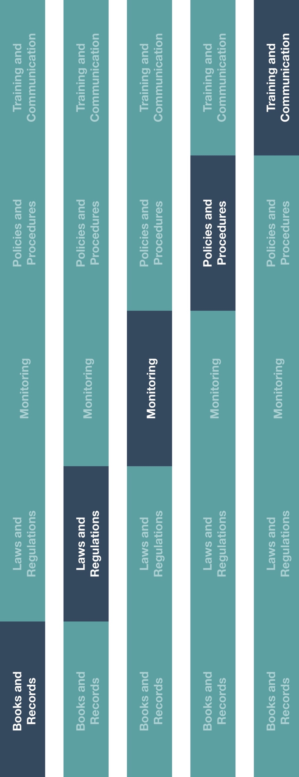

**Indirect Channel**

**Resource Center**



**Instructions**

# Provide the Payment Approval process outline to the employee(s) responsible for approving transactions and processing payments.

1. Ensure that the employee(s) responsible for this process review and understand the requirements.
2. Ensure transactions are approved by the appropriate employee level according to the delegation of authority, a leading practice that helps ensure the segregation of duties and approval controls.

**How does this benefit you?**

Maintaining accurate books and records will help you record business transactions in reasonable detail and help maintain an adequate system of internal accounting controls. Accurate books and records will assist your business with planning, budgeting, reporting and allocating resources.



|  |
| --- |
| **Description**  Distributors/agents should maintain proper supporting documentation for all payments to outline the required process related to the request, approval and disbursement of  payments to third-parties, including those considered to be high risk (e.g., healthcare professionals, intermediaries, government officials). |



**Other documentation to consider**

* Books and Records Guidance

**Payment Approval Process**

*Version 1.0*



Please note, the process of reviewing and authorizing a transaction / payment, should be memorialized (e.g., stamp, signature, date, electronically within reporting system, etc.).