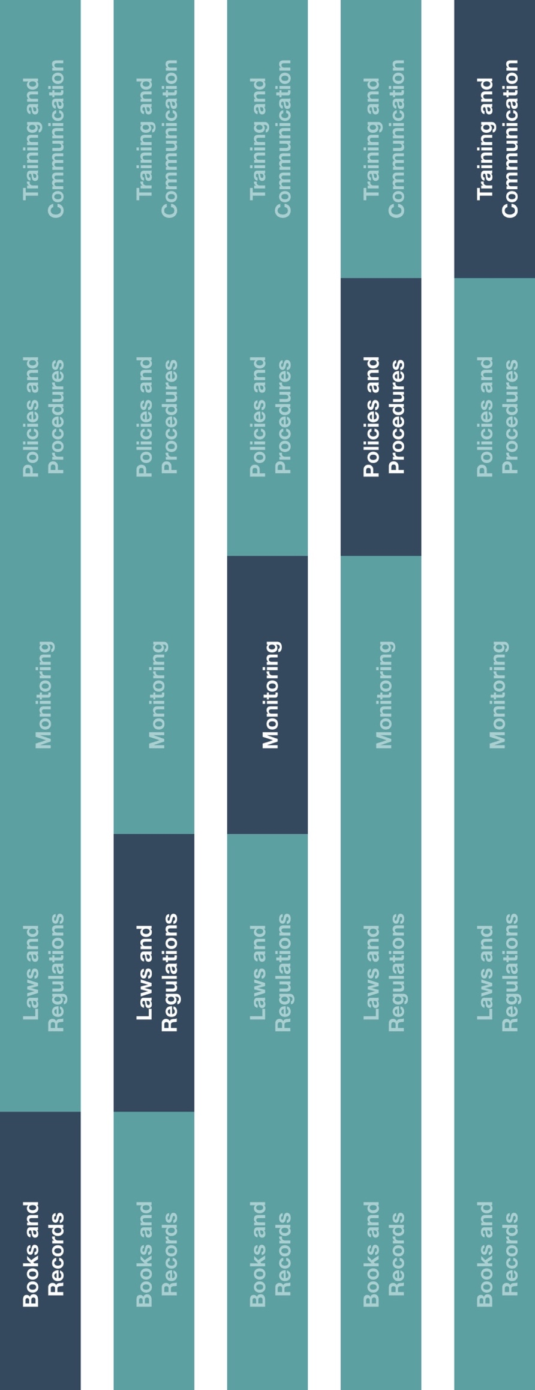

**Indirect Channel**

**Resource Center**

*Please consider all local industry code(s) (e.g., AdvaMed) and local laws when interacting with healthcare professionals or government officials



**Other documentation to consider**

* High Risk Third-Party Vendor Appointment Procedure



**Instructions**

1. Customize the highlighted sections of the High Risk Third-Party Vendor/Supplier Contract Guidance.
2. Review this guidance prior to executing any new contracts or written agreements with a vendor/supplier.
3. If your vendor/supplier is identified as a high risk third-party execute a written agreement based on this guidance.
4. Evaluate your existing vendors and identify high risk vendors/suppliers. Consider executing a written agreement with any existing high risk third-party.
5. Consult with your legal advisors prior to entering into any contractual arrangement.

**How does this benefit you?**

This guidance will help ensure that the risks associated with your high risk third-party suppliers and vendors are mitigated by incorporating certain components and provisions into written agreements and contracts with those third-parties. In addition, including these items will also help you to meet compliance requirements of your manufacturers.



|  |
| --- |
| **Description**  The High Risk Third-Party Vendor/Supplier Contract Guidance provides  recommendations and leading practices for contracting with vendors and suppliers that  are perceived to represent a high risk to your business. High risk third-parties include  those that may act on your behalf and interact with government officials, government  entities and healthcare professionals (HCPs). |



**High Risk Third-Party Vendor/Supplier Contract Guidance**

*Version 1.0*

**HIGH RISK THIRD-PARTY VENDOR/SUPPLIER CONTRACT GUIDANCE**

High risk third-parties (vendors or suppliers) present a risk to our business. Contracts and other written agreements are an important tool for mitigating this risk. This guidance outlines considerations to identify when a written contract may be needed and provisions to  be included in a written contract.

**WHEN IS A CONTRACT NEEDED?**

A written contract is required when **[insert company name]** engages a high risk third-party that has the authority to act on our behalf and is expected to interact with customers, government officials, government entities or HCPs. Examples of such third-parties include, but are not limited to, customs brokers, travel agents, vendors assisting with product registration, legal providers, tax advisors and vendors assisting with licenses and permitting.

**WHAT COMPONENTS SHOULD BE IN THE CONTRACT?**

The contract should describe the relationship and scope of work to be performed in as much detail as possible and at a minimum, include the following:

* The legal name of each contracting party.
* Responsibilities of each contracting party.
* How the vendor/supplier be compensated for any services performed.
* The term of the contractual agreement.
* Available remedies in the event either party fails to meet its obligations.

**WHAT COMPLIANCE TERMS AND CONDITIONS SHOULD BE INCLUDED?**

The following conditions will help protect us from the risks associated with third-parties and should be included in our contracts:

* A provision requiring the third-party to abide by all applicable laws and regulations, including international laws to which you may be committed to under your distribution/agent agreements with manufacturers, such as the U.S. Foreign Corrupt Practices Act.
* A provision allowing for termination of the contact if any clause is breached.
* A provision allowing you to examine or audit the books and records of the third-party to assess compliance with the contract.

*Note: Consult with your legal advisors prior to entering into any contractual arrangement with any third-party.*