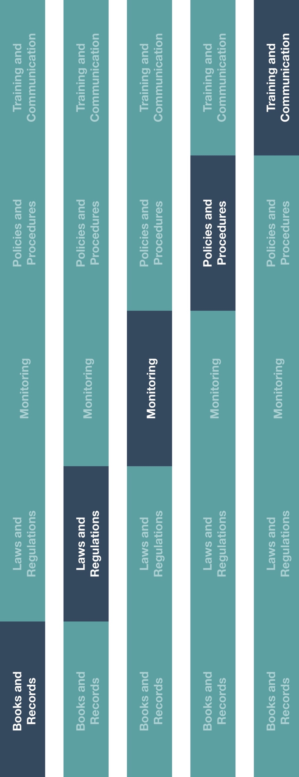

**Indirect Channel**

**Resource Center**

**How does this benefit you?**

Documenting expense reports will help ensure your books and records accurately and fairly reflect your company’s transactions in reasonable detail. It will also help ensure you have visibility into the business expenses incurred by employees and enable you to meet reporting requirements, if any, within your region/country.



|  |
| --- |
| **Description**  The Expense Report Form ensures distributors/agents appropriately document the  business purpose and approval of expenses incurred by employees (i.e., expenses  claimed by employees). |



**Instructions**

1. Provide the Expense Report Form to employee(s) and ensure they are aware of the applicable expense reimbursement policies, procedures and transaction details (e.g., attendee names, reason for the expense) that should be completed.
2. Ensure employee(s) responsible for approving expense reports understand how to review the Expense Report Form and required supporting documentation (e.g. receipts).
3. Follow your company’s policy on completing and submitting expense reports.



**Other documentation to consider**

* Travel and Expense Policy

**Expense Report Form**

*Version 1.0*

**EXPENSE REPORT FORM**

Date of submission: _________________

Employee Name: _____________________________________ Employee Title: _______________________________________

|  |  |  |  |  |  |  |  |  |  |
| --- | --- | --- | --- | --- | --- | --- | --- | --- | --- |
| **Expense Date** | **Expense Type** (e.g., meals, travel) | **Reason for Expense** | **Method of**  **Payment**  *(Cash or Credit Card)* | **Total Amt** (and currency) | **Vendor Name** | **Vendor Country** | **Related to HCP[1]/ GO[2]**  (Y or N) | **If event or meal, # of Attendees** (including yourself) | **Name(s) of Attendees and Affiliated Hospital/entity** (if applicable) |
| ***Example:***  *May 6, 2019* | *Dinner with HCP* | *Dinner with Dr. John Smith to discuss new product portfolio* | *Cash* | *76.42 INR* | *New Delhi Restaurant* | *India* | *Y* | *2* | *John Smith -*  *BLK Hospital* |
| ***Example:***  *May 7, 2019* | Business travel | *Train ticket to office* | *Credit Card* | *30 INR* | *New Delhi Train* | *India* | *No* | *1* |  |
|  |  |  |  |  |  |  |  |  |  |
|  |  |  |  |  |  |  |  |  |  |
|  |  |  |  |  |  |  |  |  |  |

Please attach all original itemized receipts

I certify that all expenses above have a legitimate business purpose and have not previously been reimbursed.

Employee Signature: ____________________________________________

Supervisor Name: ____________________________________________

Supervisor Signature: ____________________________________________ Date: __________________

1. Healthcare Professional (HCP)
2. Government Official (GO)