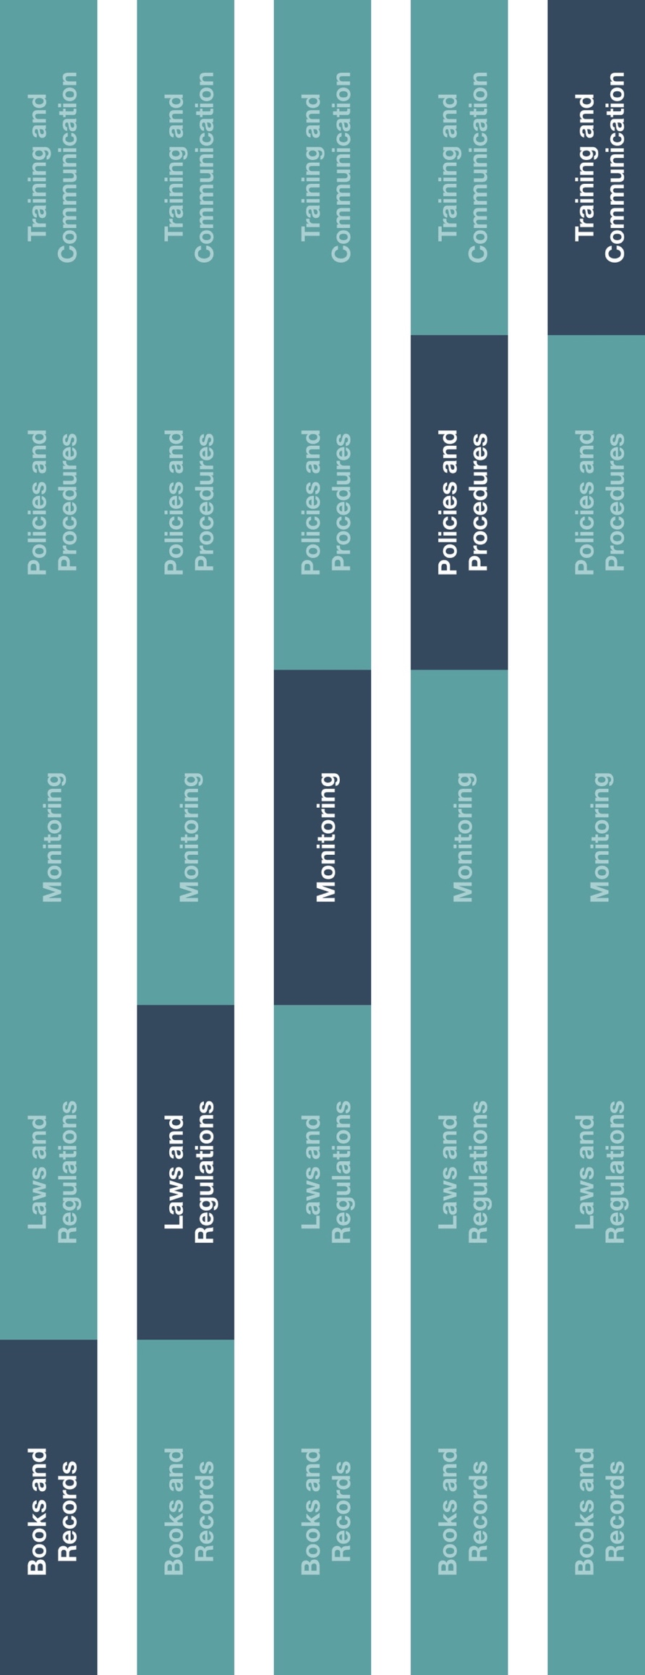

**Indirect Channel**

**Resource Center**



**Other documentation to consider**

* Sub-Distributor/Agent Appointment Procedure
* High Risk Third-Party Appointment Procedure
* Loaner, Sample & Demonstration Product Policy

**How does this benefit you?**

International regulators are increasingly focused on commercial arrangements between counterparties in the medical technology industry. Manufacturers and distributors/agents are routinely asked to justify their pricing strategy for channel partners and end customers. The Commercial Pricing Policy helps you implement a decision-making framework and supporting documentation standards to substantiate your pricing decisions.



*Please consider all local industry code(s) (e.g., AdvaMed) and local laws when interacting with healthcare professionals or government officials

|  |
| --- |
| **Description**  The Commercial Pricing Policy outlines the appropriate process for determining and documenting pricing decisions. |



**Instructions**

1. Customize the highlighted sections of the Commercial Pricing Policy.
2. Communicate the Commercial Pricing Policy to relevant employee(s), specifically those who manage sub-distributor, sub-agent, and/or customer relationships and/or are responsible for approving sales transactions.
3. Provide training to these employees on how the Commercial Pricing Policy will be implemented and executed going forward.

**Commercial Pricing Policy**

*Version 1.0*

**COMMERCIAL PRICING POLICY**

It is important that we price our products and services appropriately to achieve our business objectives and revenue goals. The process of pricing, providing discounts and rebates or extending sales incentives must always be clearly documented and approved according to the procedure outlined below. Special pricing or discounts may never be used to effectively transfer value to another party for improper purposes.

**ROUTINE PRICING**

Pricing of our products and services may occur either routinely, at defined intervals or on an ad hoc, sale-specific basis. For routine pricing decisions that will be 12 months or more), the following procedure must be performed:

1. Identify the complete list of products to be priced.
2. Utilizing the criteria approved by management, determine the target price per product or configuration. These criteria may include, but are not limited to:

* Fair market value.
* Target margin percentage.
* Expected after-sales services or warranty obligations.
* Government-established pricing lists.
* Future price changes or opportunities.

1. If possible, or required, confer with the products’ manufacturer to ensure pricing aligns with identified strategies and expectations.
2. The developed price list must be approved by **[Insert roles]**.

**AD HOC PRICING**

Occasionally, it may be appropriate to price products and services on an ad hoc, short-term basis. Such prices may utilize discounts, rebates, volume incentives or other specific pricing mechanisms. All ad hoc pricing arrangements must undergo the following procedure.:

1. The employee(s) requesting the ad hoc pricing arrangement should document, in writing, a clear business justification for extending the pricing terms requested and the products or services to which they will apply. Any relevant supporting documentation (e.g., customer emails, public announcements) should be attached to the request for reference.
2. If the impact of the ad hoc pricing arrangement results in a substantive deviation (defined as a price change of greater than **[define percentage]**) from the previously approved pricing, the arrangement must be approved in writing by the **[Insert roles].**
3. Communicate the pricing adjustment to the sub-distributor/agent or end customer and clearly indicate the period of time or specific sales to which the pricing will apply.

**SUPPORTING DOCUMENTATION**

All analyses, communications and approvals conducted in the process of determining product and service prices must be documented in writing and maintained. Examples of such documentation include, but are not limited to:

* Product or service cost analyses.
* Margin calculations.
* Government-established prices list.
* Communications between the Company and its sub-distributors/agents or end customers reflecting requests for, or any discussion of, specific pricing arrangements.
* Communications between the Company and its manufacturers reflecting discussions of pricing strategy or approvals.
* Management approvals.

This documentation should be maintained by the **[Insert department name]** according to our established document retention standards.

**QUESTIONS AND CONCERNS**

Should you have questions on how to apply this procedure contained herein or any concerns about any commercial arrangement, you should raise these to your supervisor or **[Insert role]** immediately.