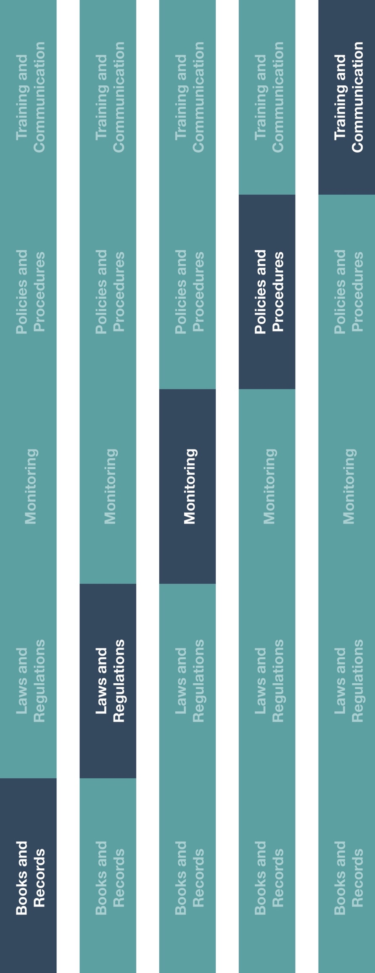

**Indirect Channel**

**Resource Center**



**Description**

Distributors/agents are required to maintain books and records that accurately and

fairly reflect their business transactions. The Books and Records Guidance outlines

best practices to ensure appropriate supporting documentation is retained for business

transactions, including those deemed to be high risk (e.g., involving government

officials, healthcare professionals, etc.).



**Other documentation to consider**

* Books and Records Requirements Training



**Instructions**

1. Provide the Books and Records Guidance to the employee(s) or third-party accounting firm(s) responsible for high risk transactions.
2. Ensure that relevant employee(s) are aware of the Books and Records Guidance and that the guidance is in line with your company policy.

**How does this benefit you?**

Maintaining accurate books and records will help you record business transactions in reasonable detail and help maintain an adequate system of internal accounting controls. Accurate books and records will assist your business with planning, budgeting, reporting and allocating resources.



**Books and Records Guidance**

*Version 1.0*

# **BOOKS AND RECORDS GUIDANCE**

Transactions must be recorded timely and accurately in order to assess our company's financial position at a point in time. Detailed records and supporting documentation are required to evidence the business purpose of our transactions and ensure our books and records are transparent and accurate. Supporting documentation includes, but is not limited to, items such as: invoices, receipts, agreements and approval forms.

# **BENEFITS OF ACCURATE BOOKS AND RECORDS**

# Maintaining accurate books and records that reasonably reflect the nature of transactions are beneficial for various reasons, which include our ability to:

# (a) Readily respond to tax and regulatory inquiries.

# (b) Make better business decisions and identify areas for opportunity.

# (c) Quickly respond with proper documentation in the case of an audit.

(d) Segregate transactional information for each of the manufacturers for which we sell product.

(e) Transactions should be recorded in accounts that reflect the true nature of the transactions. For example: meals with healthcare professionals (HCPs) should be recorded in an HCP meal account, as opposed to employee only meals which should be recorded in an employee meal account.

# **CASH PAYMENTS**

Limiting the amount of cash or cheques used as a form of payment in any transaction is a leading practice. To the extent that cash is the only option for payment (e.g., taxis, meals, select vendor payments, etc.), specific documentation must be retained for company records. See “Petty Cash” in Section 3.c. below.

# **SUPPORTING DOCUMENTATION REQUIREMENTS**

The following documentation should be retained for each type of transaction described below. To the extent you are unable to provide a full set of documentation, you should provide an explanation as to why you are unable to do so.

# **Employee Expense Reports**

* + 1. Transportation documentation detailing expenses, class of travel (e.g., itinerary, boarding pass, transportation receipts, including departure and destination locations).
    2. Lodging and meal documentation detailing expenses, attendee(s) and title(s) (e.g., itemized meal receipts, hotel folios).
    3. Expense approvals.
    4. Original itemized receipts.
    5. Explanation of the business purpose for each expense.
  1. **Disbursements (e.g., payments to vendors, suppliers, etc.)**
     1. Contracts, written agreements and addendums.
     2. Purchase orders.
     3. Invoices detailing amounts, dates of service and the types of services and/or products received.
     4. Internal approvals.
     5. Proofs of performance (e.g., delivery notices, materials).
     6. Proof of payment (e.g., cancelled check, bank statement, wire transfer advice).
     7. Correspondence.
  2. **Petty Cash**
     1. Request vouchers, including intended use and amounts.
     2. Approver sign-off and disbursement date.
     3. Receipts.
     4. Reconciliations (e.g., disbursed vs. spent) and evidence that unused funds were returned).
  3. **Grants, Donations and Sponsorships**
     1. Pre-approval documentation including request forms and business justification (e.g., HCP invitation letter / proposal, program agenda, etc.).
     2. Evidence of how the funds were utilized (e.g., agendas, white papers, research, invoices).
     3. Transportation, lodging and meal documentation.
     4. If event or conference, attendee lists, pictures of booths, etc.
  4. **Licenses, Freight, Transportation, Custom Expenses**
     1. Freight forwarder/customs broker/agent agreements.
     2. Customs/freight invoices and receipts.
     3. Customs forms and price listings.
     4. Third-party payment remittance/wire transfer forms.
     5. Government issued tax receipts.
  5. **Sales Orders**
     1. Customer purchase orders.
     2. Sales invoices (identifying any free goods, rebates, discounts and their related approvals).
     3. Shipping documentation.
     4. Price listings inclusive of any provided discounts.
     5. Evidence of payment received from the customer.