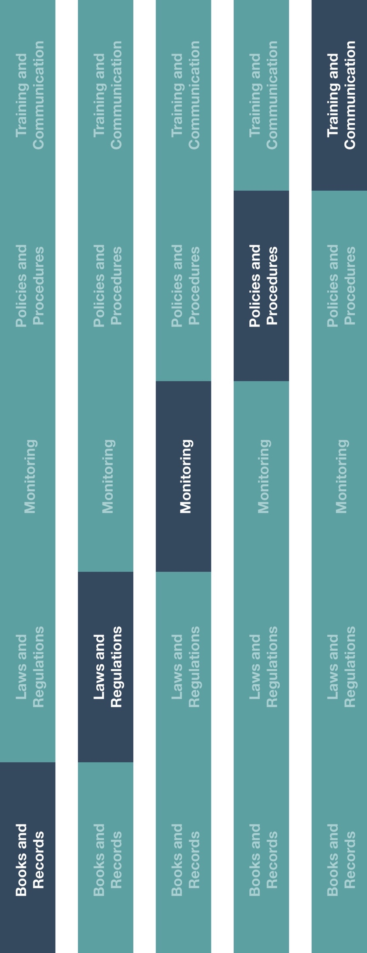

**Indirect Channel**

**Resource Center**

|  |
| --- |
| **Description**  A conflict of interest arises when an employee has a close family relationship or financial relationship with another company, employee, customer, government official, vendor or  other related party. |



**How does this benefit you?**

Identifying and managing conflicts of interest is an important component of business operations. The Conflict of Interest Policy will help establish guidelines that help ensure personal, social, financial or political interests of your employees, officers and directors do not conflict, or appear to conflict, with the interests of your company and increase the transparency of these relationships. This will also ensure employees will make objective business decisions as it related to your company’s operations.



**Instructions**

1. Customize the highlighted sections of the Conflict of Interest Policy.
2. Provide the Conflict of Interest Policy to all employees (including new employees at time of hiring).
3. Ensure employees understand their duties and responsibilities as it relates to conflicts of interest.



**Other documentation to consider**

* Code of Conduct
* Conflict of Interest Training

**Conflict of Interest Policy**

*Version 1.0*

# **CONFLICT OF INTEREST POLICY**

A conflict of interest arises when interests or activities by employees that may be, or may be perceived to be, in conflict with those of the Company or that would impact the employee’s ability to objectively carry out their duties and responsibilities or impair their commitment to the Company. Even the appearance of a conflict can damage your reputation or that of the Company. In an effort to protect the integrity of **[insert company name],** we avoid conflicts of interest as they can be detrimental to us. Employees must disclose any potential conflicts of interests or related party transactions to the Company.

**PERSONAL INVESTMENTS AND OTHER INTERESTS**

● Employees must disclose all instances in which the employee has a business relationship or any type of investment, outside of the Company’s relationship, with any of the Company’s suppliers, customers or competitors.

● Employees should not hold any outside interests that might undermine the reputation of the Company or expose the Company to unnecessary risk.

● Employees should not accept a position as an officer, partner, director or any position of authority in another entity without prior Company approval.

● Employees should disclose all additional employers and any potential conflicts of interest to the Company.

**PERSONAL RELATIONSHIPS**

* Employees must disclose all family relationships (e.g., parents, spouse, children and other immediate family) or financial relationships with suppliers, sub-distributors/agents, competitors, customers and/or business partners.
* Employees must disclose all close family relationships or financial relationships with domestic or foreign government officials, including healthcare professionals.