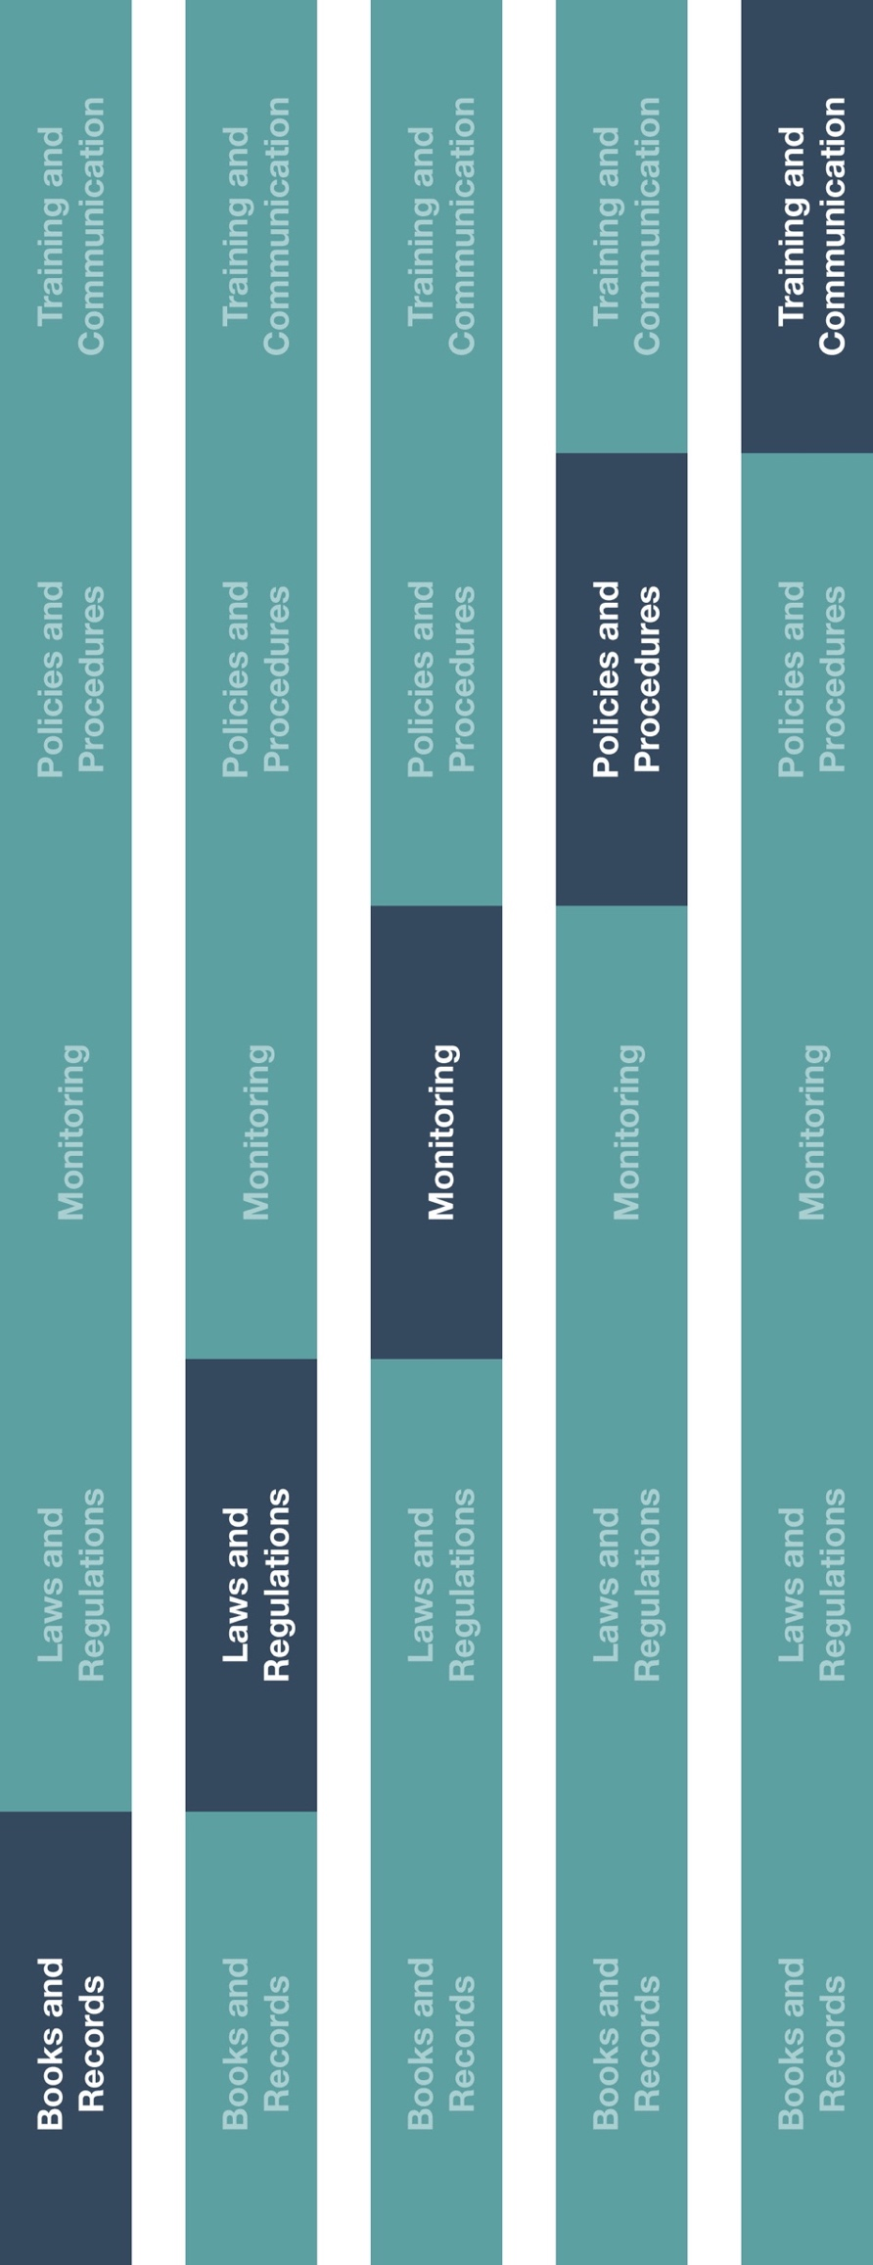

**Indirect Channel**

**Resource Center**



**Instructions**

1. Customize the highlighted sections of the Code of Conduct.
2. Provide the Code of Conduct to all officers, director and employees (including new employees at time of hiring).
3. Ensure employees understand their duties and responsibilities as it relates to your company’s commitment to ethical and lawful conduct.
4. Ensure the Code of Conduct is posted and/or accessible to all employees.

**How does this benefit you?**

The Code of Conduct helps your employees’ work is conducted in an ethical, lawful and appropriate manner.



|  |
| --- |
| **Description**  The Code of Conduct establishes fundamental guidance for employees, officers and  directors in carrying out their duties and responsibilities in compliance with your  company’s commitment to ethical and lawful behavior. |



**Other documentation to consider**

* Code of Conduct Training

**Code of Conduct**

*Version 1.0*

# **CODE OF CONDUCT**

**INTRODUCTION**

**[insert company name]**is committed to conduct our affairs ethically and lawfully. This document sets forth the Company’s expectations of how we should conduct ourselves every day. We cannot anticipate or define standards of behavior for every situation that might arise. However, we must use our best judgment to perform our job responsibilities in an ethical manner within both the letter and spirit of this document, other Company policies and national / local legislation. This document is not intended to be a substitute for more detailed policies that relate to standards of conduct, if applicable.

You must not violate any applicable laws or regulations in the course of your duties. Further, you must not engage in any misconduct that could jeopardize our Company's reputation, its client, or third-party relationships, as well as avoid situations that have any appearance of impropriety. No bribes should be offered, requested, paid or accepted.

Company resources should only be used for legitimate business purposes in the best interest of the Company. Incidents, risks and issues contrary to this document should be timely reported to the manager in charge of the employee, applicable division or operating unit.

The Code of Conduct will apply to all employees, officers, directors, principals and owners (collectively referred to as “employees”).

# **BASIC POLICIES**

# **Compliance with Laws**

The Company will conduct its business and affairs in compliance with all applicable laws, rules and regulations and in accordance with the Company’s ethical standards.

# **Conflict of Interest**

A conflict of interest occurs when a person's private interest interferes or appears to interfere in any way with the Company's interests and may also arise when an employee or director or a member of his or her family receives improper personal benefits because of his or her position with the Company. You should avoid a conflict, or an appearance of a conflict, between your personal interests, your official responsibilities and our Company’s interests. Any potential conflict of interest should be discussed with the employee’s manager.

# **Fair Dealing**

All employees will deal with the Company’s customers, suppliers, competitors and independent auditors in a fair and transparent way and will not take unfair advantage of anyone through manipulation, concealment, abuse of privileged information or misrepresentation of facts.

# **Marketing and Sales**

The Company will represent its products and services accurately and will comply with applicable regulatory and legal requirements governing the marketing and sale of its products and services.

# 

# **Recording and Reporting Information**

The Company and its employees will record and report all information accurately and honestly and will not knowingly sign or submit any document or statement that is known to be false.

# **Political Contributions**

Political contributions, or other types of support to political parties, candidates or campaigns is prohibited as it can be perceived as an attempt to gain an improper business advantage.

# **Facilitation Payments**

Facilitation payments are payments of low value intended to expedite or facilitate routine bureaucratic processes and are usually demanded by low level public officials. Illegal facilitation payments to gain improper influence are prohibited.

# **COMPLIANCE**

# 

# **Roles and Responsibilities**

It is every employee’s responsibility to understand and comply with the Code of Conduct and to report what you feel might be a violation of policy or law (including violations raised by third-parties).

# **Communications and Trainings**

Owners, officers, directors and managers must communicate the Code of Conduct to ensure that all employees within their area of responsibility understand and comply with the policies herein.

Each employee will receive relevant training and new employees will be trained upon hiring. Employees will be required to confirm in writing that they understand and comply with these policies and will report any violations that comes to their attention.

# **Reporting**

Any violation of the Code of Conduct must be reported immediately to the manager in charge of the applicable division or operating unit. Reporting may be anonymous if allowable by local law and will not be subject to retaliation of any sort.

Failure to comply with the Code of Conduct may result in disciplinary action, up to and including termination of employment, where appropriate.